# **Supplementary Information**

# Relative species abundance and population densities of the past; developing multi-species occupancy models for fossil data

# Reitan T., Ergon T. H. & Liow L.H.

## **Study system**

## The Quaternary geological history of the Wanganui Basin is one of the world’s most well-known and best-described late Neogene (Pliocene to Holocene) marine stratigraphic records (Carter & Naish 1998; Proust *et al.* 2005; Pillans 2017). The geological age-ranges of our target organisms, bryozoans, found in the outcropping geological formations of the Wanganui Basin, are thus known. Bryozoans and their substrates enter the fossil record at a relatively high rate since they are calcified and abundant in the marine environment. In addition, preservation of these tiny, sessile organisms, coupled with their morphologically-rich skeletons, is usually good enough for species-level taxonomic identifications (Jackson & Cheetham 1990). While encrusting bryozoans and their substrates (mostly bivalves but also gastropods and pebbles) can be found in geological formations that are not technically shells beds (Rust & Gordon 2011), we focused on transgressive system track (TST) shell beds that reflect similar depositional conditions (facies) to increase the comparability of the biological habitats represented by our fossil material.

## In January 2014, we examined bivalve shells/shell fragments (henceforth just “shells”) from outcropping shellbeds from different locations of about 1 m by 1 m (= “sites”) from nine geological formations within the Wanganui Basin, mostly along coastal sections and minimally along roadcuts (Fig. S1). Bryozoans have been previously recorded in each of these formations. For sites that seem to have higher preservation probabilities as perceived under field conditions, we examined c. 30 shells. Where preservation seemed poorer, we examined c. 50 bivalve shells. Throughout, we assume that shells with and without bryozoan colonies preserved, are themselves preserved with the same probability.

## In our application, the nine formations represent the time-intervals within which we sample the 1 m by 1 m sites, while shells are subsamples (i.e. repeat sampling within the sites, see main text Fig. 1).

## Of the nine geological formations (time-intervals), the oldest is the Nukumaru Limestone Formation and the youngest is the Landguard Formation (Table S1). Sites (N= 119) are selected based on accessibility while shells are randomly selected with respect to size (but are thumb nail sized or larger), position, orientation and bivalve species. Note that we cannot distinguish the ages of the sites from the same formations. While we strived to collect shells *in situ*, there are a few cases in which we collected shells from fallen blocks where safety demanded this, but where we are certain of their original *in situ* positions and hence formation assignment. Shells devoid of preserved bryozoan encrusters were noted, such that information on the number of encrusted and preserved shells versus no-encrustation observed shells are available. For this study, we examined the collected shells and tabulated the observed presence of three species easily identifiable with a 10x hand lens, namely *Antarctothoa* *tongima*, *Escharoides excavata* and *Arachnopusia unicornis* (Fig. S1)*,* conforming to typical occupancy data. We also noted down how many individual colonies of these species were observable on each shell (without washing) although we did not use this data (see Discussion). We have previously examined inter-colony interactions among bryozoans from the Wanganui Basin using non-overlapping data collected during the same field season (Liow *et al.* 2016), not to be confused with the data described here. As mentioned in the main text, we also introduce a fourth “species”, the superspecies, which represents all other bryozoan species excluding the three focal species. Fig. S2 shows a plot of the detection ratios (i.e. the number of shells with focal species of encrusting bryozoans observed divided by the total number of shells examined) for each focal species and the superspecies (without inference on occupancy), giving a graphical overview of the raw data.

Fig. S3 show detection ratio-based relative species abundances compared to relative species abundances from full model estimates. For each formation, detection ratio-based relative species abundances are calculated using the number of detections (i.e. observations) of a given species and dividing that with the total number of detections in that formation (i.e. the sum over all species). As can be seen, there are clear differences between the two estimates. Unlike in the simulations, we do not know which estimate is closest to empirical reality for each species-formation combination, but the simulations suggest the full model estimates are on average better (see Fig. 6 in the main text).

## **The beta-binomial distribution**

Here we describe the link between a per observation random effect and the beta-binomial distribution, as well as our re-parametrization. We start with the assumption that we are drawing $y$ subsamples (shells with a given species) from $n$ using the binomial distribution,

$P_{binom}\left(y | n,p_{i}\right)=\left(\begin{matrix}n \\ k\end{matrix}\right)p_{i}^{y}{(1-p_{i})}^{n-y}$ (S1)

where $i$ is the site index and $p_{i}$ is the binomial probability. We however let $p_{i}$ be subject to a per observation random effect (i.e. per site for each given species as this is the level our dataset and model is specified on), so that it is drawn independently and identically from a parametric distribution, $f(p_{i}|φ)$. Then the probability of sampling $y$ out of $n$ unconditioned on the site-dependent detection probability (i.e. the marginal probability of $y$ out of $n$ possible detections) is

$P\left(y | n,φ\right)=\int_{0}^{1}{P_{binom}\left(y | n,p_{i}\right)f(p_{i}|φ)dφ}$ (S2)

A per observation random effect will result in a change in the distribution of the data. Thus, instead of doing inference on the per observation random effects, one can instead work on this marginal probability when expressing the likelihood function.

However, the integral in Eqn S2 cannot be analytically derived for all per observation random effect distributions, $f(p_{i}|φ)$. For instance, if we used a normally-distributed random effect on the logit-transformed detection probabilities, i.e. a logit-normal distribution for $p_{i}$, the integral does not have an analytically closed expression. However, with a beta-distributed $p_{i}$, the marginal data distribution can be expressed analytically, as the beta-binomial distribution. The beta distribution is the conjugate prior for the binomial distribution, making the beta-binomial distribution a natural marginal distribution for Bayesian studies.

The beta distribution is typically expressed as $\left(p_{i} | α,β\right)=\frac{Γ\left(α+β\right)}{Γ\left(α\right)Γ\left(β\right)}p_{i}^{α-1}{(1-p_{i})}^{β-1}$. It has an expected value of $\frac{α}{α+β}$ and a variance of $\frac{αβ}{{\left(α+β\right)}^{2}(α+β+1)}$. In the context of the marginal distribution, parameters representing the overall detection probability and the overdispersion are preferred. The overall detection probability can be summarized by the expected value of the beta distribution, $p≡\frac{α}{α+β}$. The variance increases as $\left(α+β\right)$ decreases, so we could have used $\left(α+β\right)$ as an overdispersion parameter, when re-parametrizing. However, if we instead define it as $κ≡\frac{1}{α+β}$, we have an overdispersion parameter that gives no overdispersion when the value of the parameter goes to zero. With this new parametrization, the beta-distribution takes the form $f\left(p_{i} | p,κ\right)=\frac{Γ\left(1/κ\right)}{Γ\left(p/κ\right)Γ\left((1-p)/κ\right)}p_{i}^{p/κ-1}{(1-p_{i})}^{(1-p)/κ-1}$. Furthermore, the marginal distribution for getting $y$ out of $n$ samples, i.e. the beta-binomial distribution, is now expressed as:

$P(y|n,p,κ$)= $\frac{Γ\left(n+1\right)Γ\left(y+\frac{p}{κ}\right)Γ\left(n-y+\frac{1-p}{κ}\right)Γ\left(\frac{1}{κ}\right)}{Γ\left(y+1\right)Γ\left(n-y+1\right)Γ\left(n+\frac{1}{κ}\right)Γ\left(\frac{p}{κ}\right)Γ\left(\frac{1-p}{κ}\right)}$. (S3)

## This is the parametrization we use in the main text, when giving the expression for the zero-inflated beta-binomial distribution in main text Eqn. 1.

## **Prior distribution for the full model**

The non-intercept and non-random effects parameters for our modelling framework $\left\{κ_{1},⋯,κ_{S},σ_{u},σ_{v},σ_{δ,1},⋯,σ_{δ,S-1},σ_{ε,1},⋯,σ_{ε,S}\right\}$ are all strictly positive, so we log-transform them before assigning a prior distribution. We assign each parameter a prior distribution independent of the others, as one parameter does not give us knowledge of another, so that the total prior distribution is just the product of the individual parameter distributions. In all cases, we use the normal distribution as the distributional form of the prior, for the ease of deriving the hyper-parameters (expected value and standard deviation) from the bounds of a 95% credibility band and vice versa. Note that the normal distribution is the maximum entropy prior for known expected value and standard deviation (see for instance Berger 1985). Since assigning a normal distribution means that each parameter is given an informative prior, the total prior distribution is also informative. We use informative priors, for two reasons. First, to restrict the parameters such that obtaining what we deem unrealistic estimates require strong evidence (see the SI section “MCMC for statistical inference”). Second, to avoid the problems of dealing with marginal likelihoods for non-informative priors (see also Lindley 1957). The intercepts, $\left\{α_{1},⋯,α_{S-1},β_{1},⋯,β_{S}\right\}$, the log-transformed overdispersions $\left\{{{lκ}_{1}≡log⁡(κ}_{1}),⋯,{{lκ}_{S}≡(κ}_{S})\right\}$ and random-effect standard deviations, $\left\{{lσ}_{u}≡log⁡(σ_{u}),{lσ}_{v}≡log⁡(σ_{v}),{{lσ}_{δ,1}≡log⁡(σ}_{δ,1}),⋯,{lσ}_{δ,S-1}≡{log⁡(σ}_{δ,S-1}),{{lσ}_{ε,1}≡log⁡(σ}_{ε,1}),⋯,{{lσ}_{ε,S}≡log⁡(σ}_{ε,S})\right\},$ were each given the prior distribution $N(0,4)$. For the intercepts, this means that transformed back through the inverse logistic distribution, they will be logit-normally distributed with a 95% credibility band of (0.0004, 0.9996). This is a very wide distribution, while technically informative. As the intercepts are used in all models, a wide distribution will not make the prediction of one model vaguer than the other and thus we do not expect large sensitivities in the marginal likelihoods due to such distributions. On the original scale, the overdispersion and standard deviation parameters are log-normally distributed with credibility band (0.0004,2540). These are also wide priors, which should favor simple models (Lindley’s paradox, Lindley 1957). Priors for model expansions are given in the next two sections.

## **Model expansions that include explanatory variables**

Our full model (Eqn 6 main text) can be expanded to include explanatory variables such as environmental conditions. Assuming that each species has an optimal environment in which in (e.g. an optimal temperature), a quadratic relationship between the environmental explanatory variable and the logit of occupancy and/or detection probabilities is a reasonable assumption. The quadratic term we introduce is negative by construction, such that the response has maximum rather than a minimum value. We introduce these terms in the logit-parts of main text Eqn 6a and parametrize the quadratic terms according to optimum and width:

$y_{i,s}∼zβbin\left(N_{i},{p_{i,s}(θ)=logit}^{-1}\left(β_{s}+u_{f\left(i\right)}+ε_{f\left(i\right),s}-(X_{i}-μ_{s})^{2}/w_{s}^{2}\right),κ_{s},{Ψ_{i,s}(θ)=I\left(s=S\right)+I\left(s<S\right)logit}^{-1}\left(α_{s}+v_{f\left(i\right)}+δ_{f\left(i\right),s}-(X_{i}-τ_{s})^{2}/ω_{s}^{2}\right)\right)$ (S4)

Here, $X_{i}$, denotes the explanatory variables value for site *i* (which will be restricted to a given formation in our case). $μ_{s}$ and $τ_{s}$ are the optimal values of $X$ for species *s* for detection and occupancy, respectively. $w_{s}$ and $ω_{s}$ are widths describing how sensitive species *s* is to changes in $X$ for detection and occupancy, respectively, where narrow widths mean high sensitivity. The parameter set, $θ$, is the same as for the full model but the additional regression coefficients $\left\{μ_{1},⋯,μ_{S},τ_{1},{⋯,τ}_{S-1},w_{1},⋯,w_{S},ω_{1},⋯,ω_{S-1}\right\}$. Simplifications to the model (Eqn S4) are made by dropping either the detection or occupancy part, or by setting the occupancy and detection parameters equal to each other, for the optima and widths separately.

The optimum parameters, ${\{μ_{1},⋯,μ_{S},τ}_{1},⋯,τ_{S-1}\}$ were given an $N(4,2)$ prior for $δ^{18}O$ and an $N(1.4,0.2)$ prior for Mg/Ca, meaning a 95% credibility band of (0,8) and (1.0,1.8) for $δ^{18}O$ and Mg/Ca, respectively, which cover the width of the actual values in our dataset for these explanatory variables. The widths, $\{w_{1},⋯,w_{S},ω_{1},⋯,ω_{S-1}\}$ were given a $N\left(0,1\right)$ and $N(log⁡(0.1),log⁡(2))$ prior distribution on the log-scale for $δ^{18}O$ and Mg/Ca, respectively. That means they were given a log-normal distribution with 95% credibility bands (0.14,7.1) and (0.026,0.389) for $δ^{18}O$ and Mg/Ca, respectively.

## **Introducing correlations in the random effects**

Another way to expand the full model described in main text Eqn 6, is to introduce correlations in the random effects. Temporal, spatial and spatiotemporal models could be contemplated, but here we only examine temporal ones. Using the formation-dependent random effects for detection probabilities, $u_{f}$, as an example, we can introduce temporal auto-correlation by using the Ornstein-Uhlenbeck (OU) process. This relatively simple stochastic differential equation model allows us to model temporal dependencies even when the time intervals are unevenly spaced (as in our data). The advantage of modelling temporal correlation is that the model can be used for obtaining interpolated prediction for the unmeasured time intervals. The OU process can be summarized by the stationary expected value (set to 0 for the random effects) and standard deviation plus its characteristic time, which is the time for the correlation to drop to $e^{-1}$. An alternative parameterization of characteristic time is to use half-life, the time for the correlation to drop to 1/2. For a set of formations, $f∈\left\{1,⋯,F\right\}$, ordered chronologically with temporal gaps between formation $f$ and formation $f-1$ (measured between the midpoint of the start and finish of each formation) denoted as $∆t_{f}$, the distribution for the set of random effects will be:

$u_{f}\sim N\left(0,σ_{u}^{2}\right) for f=1, u_{f}|u_{f-1}\sim N\left(e^{-∆t_{f}/τ_{u}}u_{f-1},\left(1-e^{-2∆t_{f}/τ_{u}}\right)σ_{u}^{2}\right) for f>1$ (S5)

Here $σ_{u}$ is the stationary standard deviation of random effect $u$ while $τ_{u}$ is the characteristic time of this process. The random effects ${v, δ}_{s}$ and $ε_{s}$ are given auto-correlation in the same way as $u$. This only introduces four new top parameters to the parameter set, $θ$, namely, the characteristic times for the four types of random effects, $τ_{u}$, $τ_{v}$, $τ_{δ}$ and $τ_{ε}$.

The characteristics times, {$τ_{u},τ_{v}{,τ}_{δ},τ_{ε}\}$, were given a $N\left(log⁡(0.25),log⁡(10)/1.96\right)$ distribution on the log-scale, meaning a log-normal distribution with 95% credibility band (0.025My, 2.5My) on the original scale. This covers the smallest to largest time spans in our dataset.

## **MCMC for statistical inference**

In order to perform statistical inference on our hierarchical Bayesian models, we used Markov chain Monte Carlo (MCMC) methods (Metropolis et al. 1953, Hastings 1970) to sample from the posterior distribution of the parameters and random effects. Since occupancy modelling is a fairly commonly used approach, and as we did not consider our random effect expansion to be particularly elaborate, we were surprised when our initial MCMC sampling turned out to be difficult. We first used Gibbs sampling, implemented in JAGS (Plummer 2003) and Nimble (e. g. de Valpine et al. 2017) for the full model, but did not achieve convergence, as judged by visual inspection of the MCMC chains as well as Gelman’s diagnostics (Gelman et al. 2003), even when the chains were run for several days. We next experimented on attacking the full model (main text Eqn 6) with various methods in the LaplacesDemon R package (Statisticat 2018), which provides a large assemble of disparate MCMC methods, but convergence was still elusive. We then experimented on simplified versions of our occupancy model (Eqns 3-5 main text), to select promising methods implemented within LaplacesDemon that would lead us to convergence. From the results of these experiments, we chose using the Univariate Eigenvector Slice Sampler (UESS) (Thompson 2011) followed by the Adaptive Metropolis-within Gibbs (AMWG) (Roberts & Rosenthal 2007) sampler for the burn-in phase and the Component-wise Hit-And-Run Metropolis (CHARM) (Gilks & Roberts 1996) sampler for the sampling itself. All three methods are implemented in the LaplacesDemon package.

As alluded to in the main text, we started with a simplified version of the model without random effects, where the MCMC samples converged well. We then systematically added complexity, using samples from the parameters inherited from the previous model as starting points for the MCMC sampling in the next model with added parameters. Using this procedure, the full model converged (results presented in the main text). This was also the case for models with explanatory variables or OU-process autocorrelation in the random effects. However, a couple of days were needed for each MCMC chain we ran, and a large number of chains were run to test if the results were robust.

Model comparison was performed – using the Bayesian model likelihood (BML), also called the marginal likelihood (e.g. Jeffreys 1998) – for the models described in the previous paragraph (see also Table S2). The Bayes factor is the likelihood ratio of marginal likelihoods (BMLs) from the models being compared. The LaplacesDemon package provided an estimate of BML on the logarithmic scale (log-BML) for each run, though the set of estimated BMLs from different runs showed that the estimator was quite noisy, having a standard deviation of 45. Not all the runs fulfilled the LaplacesDemon’s requirements for calculating the log-BML, though for the full model we obtained 77 such estimates (out of 146 runs). That means the standard error is about 5.1. We could however not perform that many runs for all models tested. With about a quarter of that number of tested the standard error increased to 10.2. The difference between the estimated log-BML of two models will thus be 14.4, so the Bayes factor will have a multiplicative uncertainty of exp(14.4)=1.8*106 (meaning the real Bayes factor could be up to the estimate multiplied by 1.8*106 and down to the estimate divided by 1.8*106). Thus, only very large differences in log-BML consistently indicated differences between models, and only very large Bayes factors could be relied upon (such as we found while step-wise building up to the full model).

For the explanatory variable models using $δ^{18}O$ and Mg/Ca, the estimated BML uncertainty was larger than the difference between the BML for these models and the full model (without the explanatory variables, Eqn 6 in main text). To get a handle on this uncertainty, we allowed for jumping between models within an MCMC algorithm, analogous to a reversible jump (Green 1995). Specifically, we introduced index parameters that turned on and off the usage of these explanatory variables, but without expanding or contracting the parameter space, unlike standard reversible jumps algorithms. The index parameter was species-dependent (except the superspecies for occupancy), so that 3*2+4*2=14 different such parameters were used, $u_{s,O/C,o/d}$, where O stands for $δ^{18}O$, C stands for Mg/Ca, o stands for occupancy and d stands for detection. While ideally, the $u_{s,O/C,o/d}$ parameters should be in binary form, the LaplacesDemon package requires continuous parameters. We thus gave them a standard normal prior and used thresholding above 0 to switch on an effect, giving the usage of an effect a prior probability of 50%. The observational equations for a given measurement then becomes:

$y_{i,s}∼zβbin\left(N_{i},{p_{i,s}(θ)=logit}^{-1}\left(β_{s}+u_{f\left(i\right)}+ε_{f\left(i\right),s}-I(u_{s,O,d}>0)({δ^{18}O}_{i}-μ_{s,O,d})^{2}/w_{s,O,d}^{2}-I(u_{s,C,d}>0)({Mg/Ca}_{i}-μ_{s,C,d})^{2}/w_{s,C,d}^{2}\right),κ_{s},{Ψ_{i,s}(θ)=I\left(s=S\right)+I\left(s<S\right)logit}^{-1}\left(α_{s}+v_{f\left(i\right)}+δ_{f\left(i\right),s}-I(u_{s,O,o}>0)({δ^{18}O}_{i}-μ_{s,O,o})^{2}/w_{s,O,o}^{2}-I(u_{s,C,d}>0)({Mg/Ca}_{i}-μ_{s,C,o})^{2}/w_{s,C,o}^{2}\right)\right)$ (S6)

This approach allowed us to estimate the posteriori probability of including an effect: Since the prior had an equal probability for including and not including an effect, the Bayes factor for using versus not using an effect could be estimated as the number of MCMC samples of $u_{s,O/C,o/d}$ above 0 divided by the number of samples below 0. Thus, the parameter set is that of a model with two explanatory variables, plus the $u_{s,O/C,o/d}$ parameters.

## **Description of the abundance-focused model**

One can make a variant of the full model with the abundance more prominent. We do this by assigning parameters and random effects to the average observable abundances per subsample given occupancy, $λ_{f,s}(θ)$, rather than detection probabilities (as described in the main text), so that

$\log\left(λ_{i,s}(θ)\right)=β_{s}+u_{f\left(i\right)}+ε_{f\left(i\right),s}$ (S7)

Thus, the log-transform of the $λ_{f,s}$ values are assigned normally distributed random effects (centered around zero) with the same prior distribution for the intercepts and the standard deviations as before. Thus, the average observable abundance per subsample is log-normally distributed in this model. In order to avoid having to add site- and species-dependent random effects, the detection probabilities, $p_{i,s}(θ)$, are calculated and inserted into the zero-inflated beta-binomial distribution, thus letting the overdispersion there deal with the per observation random effects. Note that this is the same as assigning a cloglog link rather than a logit link in the sum of constant and random effects for the detection probabilities. We call this the abundance-focused model.

Since the only modelling difference is whether to apply a cloglog or a logit link to the detection rates, and this only affects the distribution of the random effects on the probability scale, we did not expect this modelling to make a significant difference in the estimates. A comparison between a logit-normal distribution and a cloglog-normal distribution adapted (using least squares) to the logit-normal distribution, also show that the difference between the model was minimal (Fig. S4).

When we performed the MCMC analysis and derived relative species abundance estimates, the difference between those from the original full model and the abundance-focused model was minimal (Fig. S5). There are noticeable differences for some uncertainty bands for some species-formation combinations, though that seems only to happen for formations with a lower number of sites.

We also compared the model likelihood estimates for the 77 full model MCMC runs that had log-BML estimates and the 50 abundance-focused MCMC runs, but found no significant difference between them using the Wilcoxon test. Thus, we conclude that while the abundance-focused model may have some appeal from the perspective of estimating relative species abundances, it is not significantly different from the full model for our dataset. The size of the dataset must be vastly increased (likely beyond what can realistically be obtained) for there to be any practical difference between the two models.

## **Additional results based in the empirical data**

We compared our full model (Eqn 6 in main text) with the models described in the main text as well as additional models with explanatory variables and auto-correlated random effects (Table S2). The full model performed better than any other model, except the OU (auto-regressive random effects) model. However, the BML of the OU model BML is too close to the BML of the full model when taking the uncertainty in the BML estimate into account (standard deviation of about 30 on the logarithmic scale), hence we have interpreted the full model as the best model in the main text. ). The fact that for our data, the full model is the best when compared to the simpler models, means that our prior distributions were not so wide as to preclude detecting complex models. Detecting these complexities in spite of wide priors further demonstrates the strength of the evidence for the all the elements of the full model.

Estimates and uncertainties of the 20 top parameters, $θ=\left\{α_{1},⋯,α_{S-1},β_{1},⋯,β_{S},κ_{1},⋯,κ_{S},σ_{u},σ_{v},σ_{δ,1},⋯,σ_{δ,S-1},σ_{ε,1},⋯,σ_{ε,S}\right\}$, for the full model (Eqn 6) are shown in Table S3, where parameters defined on the log- or logit-scale have been transformed back to the original scale. The 95% posterior credibility bands reveal great uncertainty about the size of the random effects, except for the formation-dependent but species-independent random effect used for detection probability. However, the model testing suggested all random effects were necessary to obtain an acceptable model fit. The overall detection and occupancy probabilities are less uncertain, except for the overall occupancy probability for *Escharoides excavata*, which almost spanned the entire interval of possible outcomes. The overdispersion factors are perhaps the parameters where the data are most informative, having uncertainty bands that span less than one order of magnitude. These credibility bands overlap, so it may be that there is a common overdispersion factor, having to do with the suitability of the sites for bryozoans and the distribution of shell sizes found. In addition, the overdispersion found may seem small ( $κ_{s}=0$ means no overdispersion). However, Fig. S6 shows a comparison of beta-binomial and binomial distributions for each species´ estimated values for overall detection probabilities and overdispersion. As can be seen, the overdispersion makes the inferred distributions noticeably different from their binomial counterparts, hence we have retained separate overdispersion estimates for each species.

The separate random effects for detection and occupancy are shown in Figs. S7-S10 and the combination of these into relative species abundance in main text Fig. 4. Fig. S7 reveals that the formation-dependent random effects common to all species has considerable variation, suggesting a noticeable influence of either variation in preservation or common abundance dynamics (given occupancy) of bryozoans. We expect bryozoans to vary in their overall preservation as there are secular changes in geological processes including erosion and sedimentation rates. However, we do not expect common abundance dynamics to matter in comparison with preservation dynamics. Fig. S8 shows that there is much more uncertainty concerning the formation-dependent (but species-independent) random effects of occupancy. We tested a model where these random effects were removed, but that model had a lower estimated BML than the full model. The figure suggests that we have less overall information about occupancy than we have about detection. Thus, when exploring regression models ( $δ^{18}O$ and Mg/Ca), we concentrated on models where only the detection probabilities were affected by the explanation variable. Fig. S9 shows the estimated species- and formation-dependent random effects that affect the detection. The focus species seem to decrease early in the formations, but bounce back up again near the end. Fig. S10 shows the same type of plot for the species- and formation-dependent random effects that influences the occupancy probabilities.

How the random effects can change detection and occupancy is perhaps best understood on the odds scale, since the logistic transformation we use for probabilities is the log-transform for odds. For the formation-dependent random effects for detection, the estimates range from -1.23 to +0.95 (see Fig. S7), meaning a multiplicative change in odds of $\exp\left(+0.95--1.23\right)=8.8$. The estimated standard deviation of this random effect was 0.86 (see Table S3), meaning that with 95% probability, each the random effects can change the odds by a multiplicative factor of $\exp\left(0.86*1.96\right)=5.4$, i.e. either multiplying or diving the median odds by as much as this amount, which we write as */5.4. This can give a better understanding of the potential of a random effect than the estimates can. The standard deviation of the formation-dependent random effects for occupancy takes the value 0.64 (Table S3), which means that there is a 95% probability of the random effects staying within */3.5=exp(0.64*1.96). These possible changes are quite large, meaning that the purely formation-dependent random effects for detection absorb a lot of the dynamics in the data common to all species. If we insert the estimates for the standard deviation of each species random effect on detection (Table S3), we get /*4.9, /*50.4, /*8.6 and /*1.6 for the multiplicative change that the random effects can have with 95% probability for *Antarctothoa tongima,* *Escharoides excavata, Arachnopusia unicornis* and the superspecies, respectively. For most species (excluding *Escharoides excavata*), the potential of the species- and formation-dependent random effects are thus smaller than or not much larger than the formation-dependent detection effects. This further underscores the importance of the formation-dependent effects. For the species- and formation-dependent random effect on occupancy, the random effects stay within */3.7, /*58000, */4600 for *A. tongima,* *E. excavata* and *A. unicornis*, respectively, with 95% probability. These huge potential multiplicative changes in the odds, underscores our uncertainty concerning the species- and formation-dependent random effects for occupancy and how they interplay with the purely formation-dependent random effects for occupancy. Also, when the occupancy probability is close to one, a huge change in the odds may not have a huge impact on the probability.

The relative species abundance estimates from the expansions to the full model compared with the full model itself are shown in Fig. S11. The models are largely in agreement (estimates of any one model are within the uncertainty bands of others) with minor differences where there are little data. The OU estimates seem to be a bit smoother than the others, which is not surprising, since when including auto-correlation, the variation from a given time interval (i.e. formation) to the next becomes somewhat restricted.

## **Abundance-specified simulation study**

We generated 100 datasets from a common parameter set described below that reflects idealized but plausible scenarios for the four species and analyzed each dataset separately. All simulations used 10 sites per formation, closer to the lower end of our empirical data (Table S1) and 60 sub-samples per site, closer to the maximum of our empirical data, the upper limit of what is reasonable in the field. The temporally constant occupancy probabilities were chosen so that they were 0.9 and 0.5 for species 2 and 3, respectively. Species 1 was given a dynamic occupancy probability increasing linearly on the logit scale so that it started with 0.119 and ended with 0.881. The superspecies (species 4 in the simulations) is assumed to be always present as in our empirical data. Thus, species 1 and 3 were both given the median occupancy probability 0.5, which was markedly lower than in our empirical dataset. This is so we can ascertain that occupancy probabilities lower than what we found for the empirical can be detected. Species 2 was given a temporally constant occupancy probability similar to what was found in the empirical data, so that the estimation could explore variation among species in the median occupancy probability.

The detection probability coefficients were set indirectly, by specifying the average abundance per subsample (and setting the unidentifiable proportionality coefficient to 1 so that there was no difference between true and observable abundance), so that $A_{f,s}=Ψ_{f,s}λ_{f,s}$. For species 3 and 4, $A_{f,s}$ was set as static (meaning no formation-dependency), $A_{f,3}=0.05$ and $A_{f,4}=1$ (i.e. on average one superspecies colony per subsample). For species 1, $A_{f,1}$ changed proportional to the occupancy probability, going from 0.0119 to 0.0881. The imposed proportionality between average abundance per subsample and occupancy, thus kept the average abundance per subsample given occupancy, and thus also the detection probability constant for that species. For species 2, $A_{f,2}$ changed linearly from 0.1 to 0.01. Since occupancy was kept constant for that species, that gave an increasing trend in the detection probabilities. These choices resulted in median detection probabilities 0.095, 0.059, 0.095 and 0.632, respectively for species 1 to 4.

Through reverse-engineering, we derived the parameters so as to result in the set of species-specific average abundance per subsample and occupancy probabilities that defined the simulation (main text Fig. 6). The inference however worked the other way, with the parameters as the fundamental quantities and occupancy and detection probabilities derived from those, and average abundance per subsample given occupancy, average abundance per subsample and relative species abundance derived from these probabilities again (see main text, section Model description, subsections 3 and 6). The overdispersion parameters were all set to 0.05, close to the average value in the dataset. The purely formation-dependent random effects were set to their expected value of 0, as we needed to fix the random effects for all 100 simulations. For the species- and formation-dependent occupancy random effects, we let species 2-4 be constant (expected value=0) but let species 1 have a linear trend, going from -2 to +2. Figs. S12-S15 show graphical representations of the chosen values of top parameters and random effects. After an inverse logistic transformation, the occupancy probability for species 1 hence changed gradually from 0.119 to 0.881 over the formations (Fig. S16). For the species- and formation-dependent detection random effects, we let species 1, 3 and 4 be constant (equal to their expected value of 0, which was achieved by letting the average abundance per subsample and the occupancy be proportional for species 1 which had occupancy dynamics), but let 2 have a random effect that varied according to the average abundance per subsample given occupancy from 0.105 to 0.011 (Fig. S17). Note that since the random effects are fixed, the log-standard deviation parameters of the random effects do not carry any meaning. We set random effects to the logarithm of the sample standard deviation for the species that had linear trends in the species- and formation-dependent random effects and set it to log(0.001) in the other cases. (We did not set the standard deviation to zero in such cases, as that does not have any meaning on the log-scale).

Fig. S18 shows the true relative species abundance compared to 5 simulations, using lines for showing the inferred dynamics for each simulation. We compare our full model estimates with detection based estimates and just as for Fig. 6 in the main text, we see that the estimates are generally better for the full model than for the detection based estimates. However, the patterns of the dynamics can perhaps be said to be on display in both instances, though the noise and bias is more prominent for the detection based estimates.

The results from the estimated top parameters, $θ=\left\{α_{1},⋯,α_{S-1},β_{1},⋯,β_{S},κ_{1},⋯,κ_{S},σ_{u},σ_{v},σ_{δ,1},⋯,σ_{δ,S-1},σ_{ε,1},⋯,σ_{ε,S}\right\},$ are shown in Fig. S12, while Figs. S13-S15 shows the various random effects, superimposed on the chosen, known values. Except for log-standard deviation parameters for random effects parameters, the top parameters and the random variables seem to be estimated well. However, as already stated, the log-standard deviation parameters for random effects do not carry much meaning. Disregarding the log-standard deviation of random effects parameters, 7 of 92 parameters and random effects had detectable bias (using a Bonferroni-corrected t-test), but the absolute value bias divided by standard deviation was on average 0.23 and never above 1.0. As for the detection and occupancy probabilities and the relative species abundances, it is possible to detect biases in some cases, but these are much smaller in absolute value than the standard deviations of the estimated parameter and random effect values. Note that our simulation scheme was somewhat idealized, so that larger standard deviations of the estimated parameters can be expected for empirical datasets. Thus, the largest source of standard error is stochastic estimation error, not bias. We hence feel confident in the ability of our model to detect the dynamics of parameters of interest.

## **Occupancy dynamics-focused simulation study**

Our estimated relative species abundances (Fig. 4 in the main text) have non-overlapping credibility intervals, thus strongly supporting a dynamic model. However, the estimated credibility intervals for occupancy probabilities are overlapping for all three species (Fig. 3 in the main text), with an absence of a clear support for a dynamic model. While estimating occupancy or its dynamics was not the object of our study, we wanted to see under which circumstances we could find clear signs of it (i.e. non-overlapping credibility intervals).

We simulated datasets, using the estimated parameters, including overdispersion as well as random effects representing dynamics, from our empirical data. This was done for number of sites per formation being 10, 20, 30, 50, 100 and 1000. The last (1000) is unrealistic given field conditions, but was added in order to see the behavior of the modelling in an extreme case. For each set of sites, the number of shells per site was set to 60, 100, 200, 400 and 1000 in the simulations. For each such combination of sites per formation and shells per site, we made 3 simulations. Ideally, more runs should be done for each combination, but the analysis of each of the 6x5x3 simulated dataset took about a week running on 4 cores, so the computational cost was already high.

The outcome of the simulation study was that even for unrealistically large sampling intensity (number of sites per formation=1000, number of shells per site=1000), occupancy dynamics could not be estimated for *Antarctothoa tongima* (see Table S4). Only for species *Escharoides excavata* could the occupancy dynamics (in the sense that the upper bound for the lowest occupancy was lower than the lower bound for the highest occupancy in the formations) reliably be estimated for number of sites per formation below 1000. However, this only occurred when we had at least 50 sites per formation and 1000 shells per site, or 100 sites per formation and 400 shells per site, both combinations of which are rather unrealistic in the field.

## **Abundance estimate sensitivity due to overdispersion of number of colonies per subsample in our empirical data**

We use Eqn. 7 in the main text to link average observable abundance per subsample given occupancy, $λ_{f,s}$, with detection probability, $p_{f,s}.$ This follows from assuming that in an occupied site, the number of colonies a given species per subsample (before taking preservation and identification into account) is Poisson distributed. The expected value of the Poisson distribution is the average abundance per subsample given occupancy, $Λ_{f,s}.$ The number of an independently sampled subset of points from a Poisson distribution is itself Poisson distributed, so the sampling here does not cause problems, and thus the number of preserved and identified colonies per subsample in an occupied site will also be Poisson distributed. However, the assumption that the number of per subsample (before sampling is dealt with) is Poisson distributed, may not hold exactly. We do have the actual counts of sampled (preserved and identifiable) colonies for each shell (subsample), and these do suggest overdispersion (variance/mean ratio) with a variance of 21.6 and a mean of 3.6. However, that does not take into account the issue of occupancy (zero-inflation) nor the sources of variation in detection probability included in our model. Still, it suggests that we may want to look into the possible effects of overdispersion in the number of colonies per subsample, and how this is related to the link between $λ_{f,s}$ and $p_{f,s}.$

The counts per subsample could have been used as data directly, but with the heavy numerical analysis needed even for the simplified data (number of shells with at least one colony for each species), such an analysis seemed unfeasible. We could however do an analysis on the count data on shell level with some simplified assumptions, using the glmmTMB package in R (Brooks et al 2017). The negative binomial distribution was used as it is an overdispersed version of the Poisson distribution with an analytical expression for the probability distribution. We used the parametrization called “nbinom2” in the glmmTMB package, where the negative binomial distribution is re-parametrized to two parameters, one representing the mean, $m$, and one representing the overdispersion, $r$. The variance/mean ratio is then $1+\frac{m}{r}.$ The glmmTMB package also allows for zero-inflation, which allows us a simple way of dealing with the issue of occupancy (as lack of occupancy is modelled as zero-inflation). Note that it has an overdispersion parameter that is defined so that when it goes to infinity, there is no overdispersion (i.e. Poisson distribution), while the closer it is to zero the more overdispersion there is.

We first analyzed each species alone, using a model with formation and site as random effects for the expected value and formation as random effect for the zero-inflation. The overdispersion parameter was estimated to 1.0 for *Antarctothoa tongima,* 12.6 for *Escharoides excavata, 2.1 for Arachnopusia unicornis* and 3.1 for the superspecies. With a mean of 0.37, 0.17, 0.12 and 3.5 for *A. tongima*, *E. excavata, A. unicornis* and the superspecies respectively, that yielded a variance to mean ratio (overdispersion) of 1.37, 1.02, 1.06 and 2.1. We regarded these estimates as fairly uncertain though, but a combined analysis could narrow down that uncertainty.

When collating all the counts into one dataset, putting on a species label and using species as a fixed effect in a combined model for all species (with formation as a fixed effect since the analysis could not handle it as a random effect, and with an interaction term between formation and species to capture the species-dynamics), we got an estimate of 3.6 for the overdispersion parameter. A bootstrap analysis suggested an 95% uncertainty band between 3 to 4, thus an overdispersion ranging from 1.03 as a best-case scenario for *A. tongima* to 2.2 as a worst-case scenario for the superspecies.

With a re-parametrized negative binomial distribution representing the number of preserved colonies, $P_{NB}\left(k | m,r\right)=\left(\begin{matrix}k+r-1 \\ k\end{matrix}\right){\left(\frac{r}{m+r}\right)}^{r}{\left(\frac{m}{m+r}\right)}^{k}$, the link between detection probability, $p_{f,s}$, and average observable abundance per subsample given occupancy, $λ_{f,s}$, becomes:

$p_{f,s}=P\left(preserved colonies>0\right)=1-P_{NB}\left(k=0|m=λ_{f,s},r\right)=1-{\left(\frac{r}{r+λ_{f,s}}\right)}^{r}$ (S8)

where $r$ is the overdispersion parameter of the negative binomial distribution. When $r→∞$, Eqn 7 in the main text is recovered. Using the link function for 5 different values, 1 (lowest estimate for single species, i.e highest overdispersion), 3 (lower bound for overall overdispersion parameter), 4 (higher bound for overall overdispersion parameter),12 (highest estimate for single species, i.e. lowest overdispersion), 100 (for testing high values for the overdispersion parameter), we compared estimates to that from Eqn 7 in figure S19. As can be seen, for the overdispersion estimates from the shell analysis on the combined species dataset, there is almost no noticeable difference between the relative species abundance estimates from that assumption and from the assumption used in the main text. Only for the lowest estimate of the overdispersion parameter from a single species (i.e. the highest overdispersion suggested by any piece of the shell dataset), did we get estimates that came close to the uncertainty bands from the original model, and only for some species-formation combinations such as *Escharoides excavata* and the superspecies for the first time period (where there is more data than in the other time periods, see figure S19). As the single-species estimate is laden with more uncertainty and we see no reason to assume that the overdispersion is different for different species, we conclude that deviations from the Poisson distribution due to overdispersion is not a serious problem for our dataset. But this should be evaluated for each new application as the nature of different datasets can differ.

**Comparison of abundance-detection probability link in our work and in Yamaura *et al.* (2011)**

In Yamaura et al. (2011), the number of individuals within a site is linked to the detection probability with the formula

$p_{i,j}=1-{(1-r_{i,j})}^{Z_{i,j}}$ (S9)

where $i$ is the species, $j$ is the site, $r_{i,j}$ is the detection probability per individual (of the given species at the given site), $Z_{i,j}$ is the number of individuals and $p_{i,j}$ is the probability of detection of any individual of the given species at that site. This follows from a binomial process, where each individual can be detected or not detected, independent of other individuals at the site. The probability of zero detections of $Z_{i,j}$ are under the binomial distribution ${(1-r_{i,j})}^{Z_{i,j}}$. Thus, the probability of at least one detection is $1-{(1-r_{i,j})}^{Z_{i,j}}$.

Our Poisson process-based formula linked the average observable abundance per subsample given occupancy, $λ_{f,s}$, to the corrected detection probability, $p_{f,s}^{*}$ as

$p_{f,s}^{*}=P\left(number of preserved individuals>0\right)=1-e^{-λ_{f,s}}$. (S10)

Note that we need to use corrected detection probabilities in our application (see main text) given our context, while Yamaura *et al.* (2011) had no need for these. Furthermore the index $s$ in our notation replaces $i$ in Yamaura’s notation (and the order of our indexing is reversed compared to Yamaura's) and $f$ is formation for us but equivalent to site $j$ in Yamaura. We can then rewrite Yamaura’s formula using our notation as $p_{f,s}^{*}=1-e^{Z_{f,s}log⁡(1-r_{f,s})}$. Our average observable abundance per subsample given occupancy, $λ_{f,s}$ is only related to the real abundance over the whole region through an unknown proportionality constant. This proportionality constant depends on the preservation of subsamples, the preservation of individuals per subsample, the proportion of individuals that attach to subsamples (shells) and the regional abundance of the subsamples. Thus, with $λ_{f,s}$ being proportional to $Z_{f,s}$, we can write Eqn. (S9) as Eqn. (S10).

This may seem as just a coincident in formulas. However, the binomial distribution converges to a Poisson distribution when the detection probability goes to zero while the number of individuals go to infinity in proportion. And since a change in the number of individuals and detection probability do not cause a change in the form of Eqn. S9, the Poisson version of this equation should have the same form. The Poisson distribution is an approximation in our case, since the number of individuals within a region within each sampling interval is huge but finite. Thus, we could instead have used the formulation of Yamaura *et al.* (2011), but the individual detection probability for a random subsample from some time point in the formation would be extremely low and not identifiable. The fact that we are averaging over a huge region and over a large chunk of time means we had to make some approximations, in order to formulate the link with identifiable quantities.

## **References cited**

Berger, J. O. 1985. Statistical Decision Theory and Bayesian Analysis (Second ed.). Springer.

Brooks, M.E., Kristensen, K., van Benthem, K.J., Magnusson, A., Berg, C.W., Nielsen, A., Skaug, H.J., Maechler, M. and Bolker, B.M. 2017. glmmTMB Balances Speed and Flexibility Among Packages for Zero-inflated Generalized Linear Mixed Modeling. The R Journal **9**(2):378–400.

Carter, R.M. and Naish T.R. 1998. A review of Wanganui Basin, New Zealand: global reference section for shallow marine, Plio-Pleistocene (2.5-0 Ma) cyclostratigraphy. *Sediment. Geol.* **122**:37–52.

de Valpine, P., Turek, D., Paciorek, C.J., Anderson-Bergman, C., Lang, D.T. and R. Bodik. 2017. Programming with models: writing statistical algorithms for general model structures with NIMBLE, Journal of Computational and Graphical Statistics, **26**(2):403-413. Gelman, A., Carlin, J.B., Stern, H.S. and D.B. Rubin. 2003. Bayesian Data Analysis, 2nd edition, CRC Press.

Gilks, W. and G. Roberts. 1996. Strategies for Improving MCMC. In Gilks, W., Richardson, S. and D. Spiegelhalter (eds.), Markov Chain Monte Carlo in Practice, p. 89-114. Chapman & Hall, Boca Raton, FL.P.J. Green. 1995. Reversible Jump Markov Chain Monte Carlo Computation and Bayesian Model Determination. Biometrika **82**(4):711-732.

Hastings, W.K. 1970. Monte Carlo sampling methods using Markov chains and their applications. Biometrika. **57**(1):97–109.

Jackson, J.B.C. & Cheetham, A.H. (1990). Evolutionary significance of morphospecies - a test with cheilostome Bryozoa. Science**248**:579–583.

Jeffreys, H. 1998 [1961]. The Theory of Probability (3rd ed.). Oxford, England.

[Lindley, D.V.](https://en.wikipedia.org/wiki/Dennis_Lindley) 1957. A statistical paradox. [Biometrika](https://en.wikipedia.org/wiki/Biometrika) **44**(1-2):187-192.

MacKenzie, D., J. Nichols, A. Royle, K. Pollock, L. Bailey, and J. Hines. 2017. Occupancy Estimation and Modeling, 2nd edition: Inferring Patterns and Dynamics of Species Occurrence. Academic Press.

Metropolis, N., Rosenbluth, A.W., Rosenbluth, M.N., Teller, A.H. and E. Teller. 1953. Equation of state calculations by fast computing machines. Journal of Chemical Physics. **21**(6):1087–1092.

Pillans, B. 2017. Quaternary stratigraphy of Whanganui Basin—a globally significant archive. In: *Landscape and Quaternary Environmental Change in New Zealand* (ed. Shulmeister, J.). Atlantis Press, Paris, pp. 141–170.

Plummer, M. 2003. JAGS: A program for analysis of Bayesian graphical models using Gibbs sampling. Proceedings of the 3rd International Workshop on Distributed Statistical Computing; Vienna, Austria.

Proust, J.N., Lamarche, G., Nodder, S. & Kamp, P.J. 2005. Sedimentary architecture of a Plio-Pleistocene proto-back-arc basin: Wanganui Basin, New Zealand. Sedimentary Geology **181**:107–145.

Roberts, G. and J. Rosenthal. 2007. Coupling and ergodicity of adaptive Markov Chain Monte Carlo algorithms. Journal of Applied Probability **44**:458-475.

Rust, S. & Gordon, D. 2011. Plio-Pleistocene bryozoan faunas of the Wanganui Basin, New Zealand: stratigraphic distribution and diversity. New Zealand Journal of Geology and Geophysics **54**: 151–165.

Statisticat, LLC. 2018. LaplacesDemon: Complete Environment for Bayesian Inference. Bayesian-Inference.com. R package version 16.1.1. [https://web.archive.org/web/20150206004624/http://www.bayesian-inference.com/software]

Thompson, M.D. 2011. Slice sampling with multivariate steps. University of Toronto PhD. Thesis http://hdl.handle.net/1807/31955

Yamaura, Y., J. Andrew Royle, K. Kuboi, T. Tada, S. Ikeno, and S. Makino. 2011: Modelling community dynamics based on species-level abundance models from detection/nondetection data. Journal of Applied Ecology 48:67–75.

**Table S1: Summary of data**. The names of the formations (youngest in the first row and oldest in the last row), the age range (from Carter and Naish 1998) and the number of sites N*i* sampled in each formation are given.

|  |  |  |  |
| --- | --- | --- | --- |
|  | Formation | Age (millions of years ago) | Ni |
| 1 | Landguard | |  | | --- | | 0.32-0.30 | | 2 |
| 2 | Upper Castlecliff Shellbed | |  |  | | --- | --- | | 0.40-0.38 |  | | 13 |
| 3 | Shakespeare Cliff Basal Sand Shellbed | |  | | --- | | 0.43-0.40 | | 6 |
| 4 | Tainui Shellbed | |  |  | | --- | --- | | 0.51-0.43 |  | | 10 |
| 5 | Lower Castlecliff Shellbed | |  |  | | --- | --- | | 0.58-0.52 |  | | 13 |
| 6 | Upper Kai-iwi Shellbed | |  |  | | --- | --- | | 0.69-0.62 |  | | 12 |
| 7 | Lower Kai-iwi Shellbed | |  |  | | --- | --- | | 0.97-0.93 |  | | 5 |
| 8 | Nukumaru Brownsand | |  |  | | --- | --- | | 2.03-1.97 |  | | 21 |
| 9 | Nukumaru Limestone | |  | | --- | | 2.29-2.08 | | 38 |

**Table S2. Comparing models of varying complexity.** The models in each row include parameters marked with an “x”. The evidence for or against one model compared to another is summarized by the Bayes factor, which is the BML of the model examined divided by the BML of the model it is compared to. Our full model (Eqn 6) is highlighted in blue and has Bayes Factor of 1, since we use the BML of the full model as the reference. A Bayes factor >1 indicates support for the full model while a Bayes-factor<1 indicates preference for the alternative model. Note that there is great uncertainty (*/ ${2*10}^{6}$) in the estimated BMLs except for the comparisons between the full model and the explanation variable models (which used a model jump algorithm).

|  |  |  |  |  |  |  |  |  |  |
| --- | --- | --- | --- | --- | --- | --- | --- | --- | --- |
| $$v_{f\left(i\right)}$$ | $$u_{f\left(i\right)}$$ | $$ε_{f\left(i\right),s}$$ | $$δ_{f\left(i\right),s}$$ | Occupany explanatory variable | Detection explanatory variable | Mg/Ca  Occupany explanatory variable | Mg/Ca  Detection explanatory variable | OU | Bayes factor |
| x |  |  |  |  |  |  |  |  | 8*10220 |
| x | x |  |  |  |  |  |  |  | 7*10151 |
| **x** | **x** | **x** | **x** |  |  |  |  |  | **1 (full model)** |
| x | x | x | x | x |  |  |  |  | 2.6 |
| x | x | x | x |  | x |  |  |  | 1.2 |
| x | x | x | x | x | x |  |  |  | 4.2 |
| x | x | x | x |  |  | x |  |  | 10 |
| x | x | x | x |  |  |  | x |  | 14 |
| x | x | x | x |  |  | x | x |  | 170 |
| x | x | x | x |  |  |  |  | x | 0.0004 |

**Table S3. Parameter estimates from the full model.** Parameter estimates are given with their 95% posterior credibility intervals.

|  |  |  |
| --- | --- | --- |
| Parameter name | Posterior mean | 95% credibility band |
| $κ_{1}$, overdispersion parameter, *Antarctothoa tongima* | 0.093 | 0.050 ­– 0.15 |
| $κ_{2}$, overdispersion parameter, *Escharoides excavata* | 0.051 | 0.018 – 0.11 |
| $κ_{3}$, overdispersion parameter, *Arachnopusia unicornis* | 0.040 | 0.012 – 0.084 |
| $κ_{4}$, overdispersion parameter, superspecies | 0.073 | 0.049 – 0.10 |
| invlogit($β_{1})$, overall detection probability, *A. tongima* | 0.054 | 0.020 – 0.12 |
| invlogit($β_{2})$, overall detection probability, *E. excavata* | 0.029 | 0.0010 – 0.12 |
| invlogit($β_{3})$, overall detection probability, *A. unicornis* | 0.021 | 0.0044 – 0.056 |
| invlogit($β_{4})$, overall detection probability, superspecies | 0.42 | 0.28 – 0.60 |
| invlogit($α_{1})$, overall occupancy probability, *A. tongima* | 0.97 | 0.87 – 1.0 |
| invlogit($α_{2})$, overall occupancy probability, *E. excavata* | 0.73 | 0.022 – 1.0 |
| invlogit($α_{3})$, overall occupancy probability, *A. unicornis* | 0.88 | 0.33 – 1.0 |
| $σ_{u}$, formation-dependent random effect standard deviation for detection common for all species | 0.86 | 0.42 – 1.7 |
| $σ_{v}$, formation-dependent random effect standard deviation for occupancy common for all species | 0.64 | 0.0004 – 3.9 |
| $σ_{ε,1}$, formation-dependent random effect standard deviation for detection for *A. tongima* | 0.82 | 0.0028 – 1.8 |
| $σ_{ε,2}$, formation-dependent random effect standard deviation for detection for species *E. excavata* | 2.0 | 0.0051 – 5.6 |
| $σ_{ε,3}$, formation-dependent random effect standard deviation for detection for species *A. unicornis* | 1.1 | 0.0059 – 2.6 |
| $σ_{ε,4}$, formation-dependent random effect standard deviation for detection for superspecies | 0.23 | 0.0002 – 0.98 |
| $σ_{δ,1}$, formation-dependent random effect standard deviation for occupancy for *A. tongima* | 0.64 | 0.0002 – 4.3 |
| $σ_{δ,2}$, formation-dependent random effect standard deviation for occupancy ion for species *E. excavata* | 4.4 | 0.0005 – 29 |
| $σ_{δ,3}$, formation-dependent random effect standard deviation for occupancy for species *A. unicornis* | 3.2 | 0.0004 – 19 |

**Table S4: Results from the simulations on occupancy dynamics.** For each combination of number of sites per formation and number of shells per site, 3 simulated datasets were analyzed using the same MCMC analysis as performed on the empirical dataset. For each species, the highest value from all formations of the lower band of the 95% credibility interval (Max L) of the occupancy probability is shown together with the lowest value from all formations of the upper band of the 95% credibility interval (Min U). For the cases where Max L is larger than Min U, the 95% credibility bands of the estimated occupancy probabilities are not overlapping. Such cases are marked in yellow.

|  |  |  |  |  |  |  |  |
| --- | --- | --- | --- | --- | --- | --- | --- |
| No. sites per formation | No. shells  per site | *Antarctothoa tongima* | | *Escharoides excavata* | | *Arachnopusia unicornis* | |
| Max L | Min U | Max L | Min U | Max L | Min U |
| 10 | 60 | 0.915  0.801  0.897 | 1.000  1.000  1.000 | 0.777  0.843  0.729 | 1.000  1.000  0.999 | 0.792  0.836  0.757 | 1.000  1.000  1.000 |
| 10 | 100 | 0.838  0.820  0.864 | 1.000  1.000  0.999 | 0.772  0.550  0.684 | 1.000  0.923  0.986 | 0.908  0.780  0.788 | 1.000  0.998  1.000 |
| 10 | 200 | 0.830  0.829  0.892 | 1.000  1.000  1.000 | 0.541  0.829  0.544 | 0.859  1.000  0.838 | 0.734  0.849  0.672 | 0.999  1.000  0.999 |
| 10 | 400 | 0.810  0.903  0.912 | 1.000  1.000  1.000 | 0.729  0.703  0.571 | 0.996  0.992  0.764 | 0.852  0.823  0.763 | 1.000  1.000  0.996 |
| 10 | 1000 | 0.900  0.890  0.882 | 1.000  1.000  1.000 | 0.772  0.574  0.692 | 0.930  0.802  0.968 | 0.764  0.646  0.754 | 0.995  0.952  0.972 |
| 20 | 60 | 0.870  0.885  0.889 | 1.000  1.000  1.000 | 0.587  0.849  0.662 | 0.992  1.000  0.871 | 0.884  0.709  0.757 | 1.000  1.000  0.999 |
| 20 | 100 | 0.946  0.926  0.904 | 1.000  1.000  1.000 | 0.649  0.890  0.795 | 0.962  1.000  0.945 | 0.805  0.728  0.937 | 0.996  0.945  1.000 |
| 20 | 200 | 0.941  0.903  0.958 | 1.000  1.000  1.000 | 0.756  0.782  0.833 | 0.975  0.982  0.981 | 0.737  0.718  0.896 | 0.972  0.973  1.000 |
| 20 | 400 | 0.920  0.898  0.910 | 0.999  0.996  0.995 | 0.719  0.795  0.718 | 0.913  0.990  0.883 | 0.767  0.795  0.866 | 0.950  0.984  0.998 |
| 20 | 1000 | 0.888  0.968  0.955 | 0.991  1.000  1.000 | 0.723  0.773  0.706 | 0.943  0.965  0.948 | 0.791  0.775  0.791 | 0.944  0.978  1.000 |
| 30 | 60 | 0.955  0.918  0.855 | 1.000  1.000  0.993 | 0.706  0.769  0.832 | 0.948  0.924  0.988 | 0.791  0.778  0.905 | 1.000  0.996  1.000 |
| 30 | 100 | 0.962  0.966  0.943 | 1.000  1.000  1.000 | 0.734  0.843  0.749 | 0.955  0.998  0.946 | 0.860  0.779  0.773 | 0.997  0.988  0.970 |
| 30 | 200 | 0.913  0.913  0.911 | 0.995  0.998  0.999 | 0.611  0.777  0.727 | 0.827  0.947  0.893 | 0.843  0.739  0.847 | 0.979  0.944  0.996 |
| 30 | 400 | 0.921  0.929  0.940 | 0.995  0.999  0.999 | 0.754  0.814  0.701 | 0.807  0.966  0.869 | 0.873  0.893  0.791 | 0.975  0.994  0.955 |
| 30 | 1000 | 0.956  0.916  0.930 | 0.997  0.993  0.994 | 0.772  0.799  0.786 | 0.786  0.734  0.921 | 0.843  0.796  0.764 | 0.969  0.946  0.925 |

Table S4: Results from the simulation study on occupancy dynamics (con’t).

|  |  |  |  |  |  |  |  |
| --- | --- | --- | --- | --- | --- | --- | --- |
| No. sites per formation | No. shells per site | *Antarctothoa tongima* | | *Escharoides excavata* | | *Arachnopusia unicornis* | |
| Max L | Min U | Max L | Max L | Min U | Max L |
| 50 | 60 | 0.876  0.903  0.908 | 0.973  1.000  0.999 | 0.821  0.871  0.805 | 0.953  0.967  0.965 | 0.833  0.811  0.849 | 0.987  0.960  0.988 |
| 50 | 100 | 0.929  0.981  0.935 | 0.999  1.000  1.000 | 0.880  0.832  0.779 | 0.992  0.943  0.890 | 0.806  0.857  0.865 | 0.947  0.943  0.957 |
| 50 | 200 | 0.943  0.880  0.928 | 0.990  0.971  0.992 | 0.805  0.688  0.837 | 0.954  0.832  0.937 | 0.869  0.765  0.880 | 0.953  0.912  0.985 |
| 50 | 400 | 0.943  0.955  0.917 | 0.994  0.999  0.980 | 0.791  0.794  0.794 | 0.909  0.888  0.794 | 0.883  0.878  0.863 | 0.972  0.980  0.970 |
| 50 | 1000 | 0.925  0.945  0.925 | 0.986  0.986  0.987 | 0.857  0.881  0.823 | 0.752  0.759  0.673 | 0.833  0.881  0.879 | 0.939  0.983  0.950 |
| 100 | 60 | 0.973  0.935  0.957 | 1.000  1.000  1.000 | 0.873  0.856  0.820 | 0.968  0.935  0.924 | 0.876  0.874  0.906 | 0.971  0.980  0.991 |
| 100 | 100 | 0.941  0.966  0.943 | 0.991  1.000  0.990 | 0.835  0.925  0.863 | 0.918  0.985  0.951 | 0.896  0.868  0.802 | 0.978  0.962  0.922 |
| 100 | 200 | 0.960  0.959  0.937 | 0.988  0.992  0.989 | 0.839  0.902  0.853 | 0.902  0.813  0.705 | 0.895  0.908  0.879 | 0.978  0.978  0.972 |
| 100 | 400 | 0.960  0.949  0.960 | 0.989  0.991  0.985 | 0.868  0.859  0.845 | 0.685  0.727  0.739 | 0.868  0.896  0.892 | 0.942  0.955  0.945 |
| 100 | 1000 | 0.963  0.953  0.950 | 0.993  0.989  0.988 | 0.860  0.920  0.898 | 0.733  0.705  0.750 | 0.875  0.870  0.907 | 0.953  0.945  0.976 |
| 1000 | 60 | 0.962  0.969  0.959 | 0.971  0.985  0.979 | 0.908  0.894  0.895 | 0.720  0.657  0.696 | 0.937  0.913  0.915 | 0.961  0.944  0.943 |
| 1000 | 100 | 0.969  0.964  0.965 | 0.985  0.979  0.980 | 0.901  0.902  0.899 | 0.669  0.659  0.678 | 0.926  0.919  0.920 | 0.933  0.914  0.948 |
| 1000 | 200 | 0.964  0.963  0.963 | 0.976  0.975  0.977 | 0.894  0.900  0.888 | 0.650  0.674  0.683 | 0.929  0.912  0.913 | 0.942  0.927  0.934 |
| 1000 | 400 | 0.960  0.974  0.964 | 0.973  0.975  0.974 | 0.898  0.902  0.879 | 0.639  0.624  0.627 | 0.918  0.928  0.910 | 0.919  0.913  0.853 |
| 1000 | 1000 | 0.971  0.964  0.967 | 0.982  0.974  0.977 | 0.908  0.891  0.901 | 0.625  0.646  0.627 | 0.914  0.902  0.925 | 0.784  0.790  0.828 |

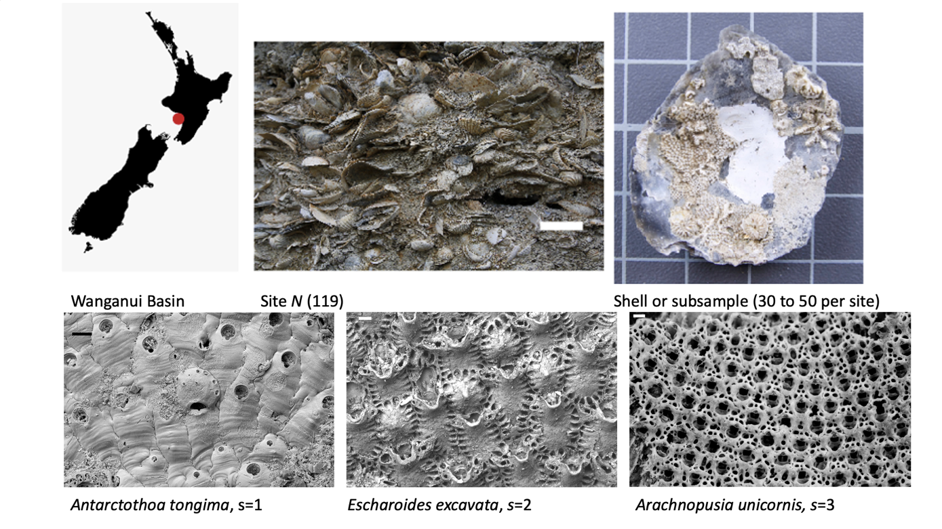

**Figure S1: Illustration of study system.** Top left panel shows a silhouette of New Zealand with a red circle marking the location of the Wanganui Basin, our study area. A site within any given time interval (Formation, see Table S1), is an approximately 1 by 1 m of a section of a Formation, partially depicted in the panel beside the silhouette (white scale bar c. 5 cm). Top right panel shows a shell (subsample) where colonies (= genetic individuals) of multiple bryozoan species are visible (square grids on which the shell lays is 1cm by 1cm). Scanning Electron micrographs (lower panels) show the three focal species where scale bars are c. 100 microns. S are their indices in our analyses and where any other bryozoan that is not one of these are given the index s = 4.



**Figure S2: Raw data plot.** The plotted points are detection ratios, i.e. the number of shells (subsamples) on which a given species is observed given the number of shells examined for each site (N = 119). The midpoint of the age range of the specific formations (time-intervals) from which these sites are sampled are plotted on the x-axis (see Table S1 for details) and the lines are drawn through the means of detection ratios in each formation for visual guidance.

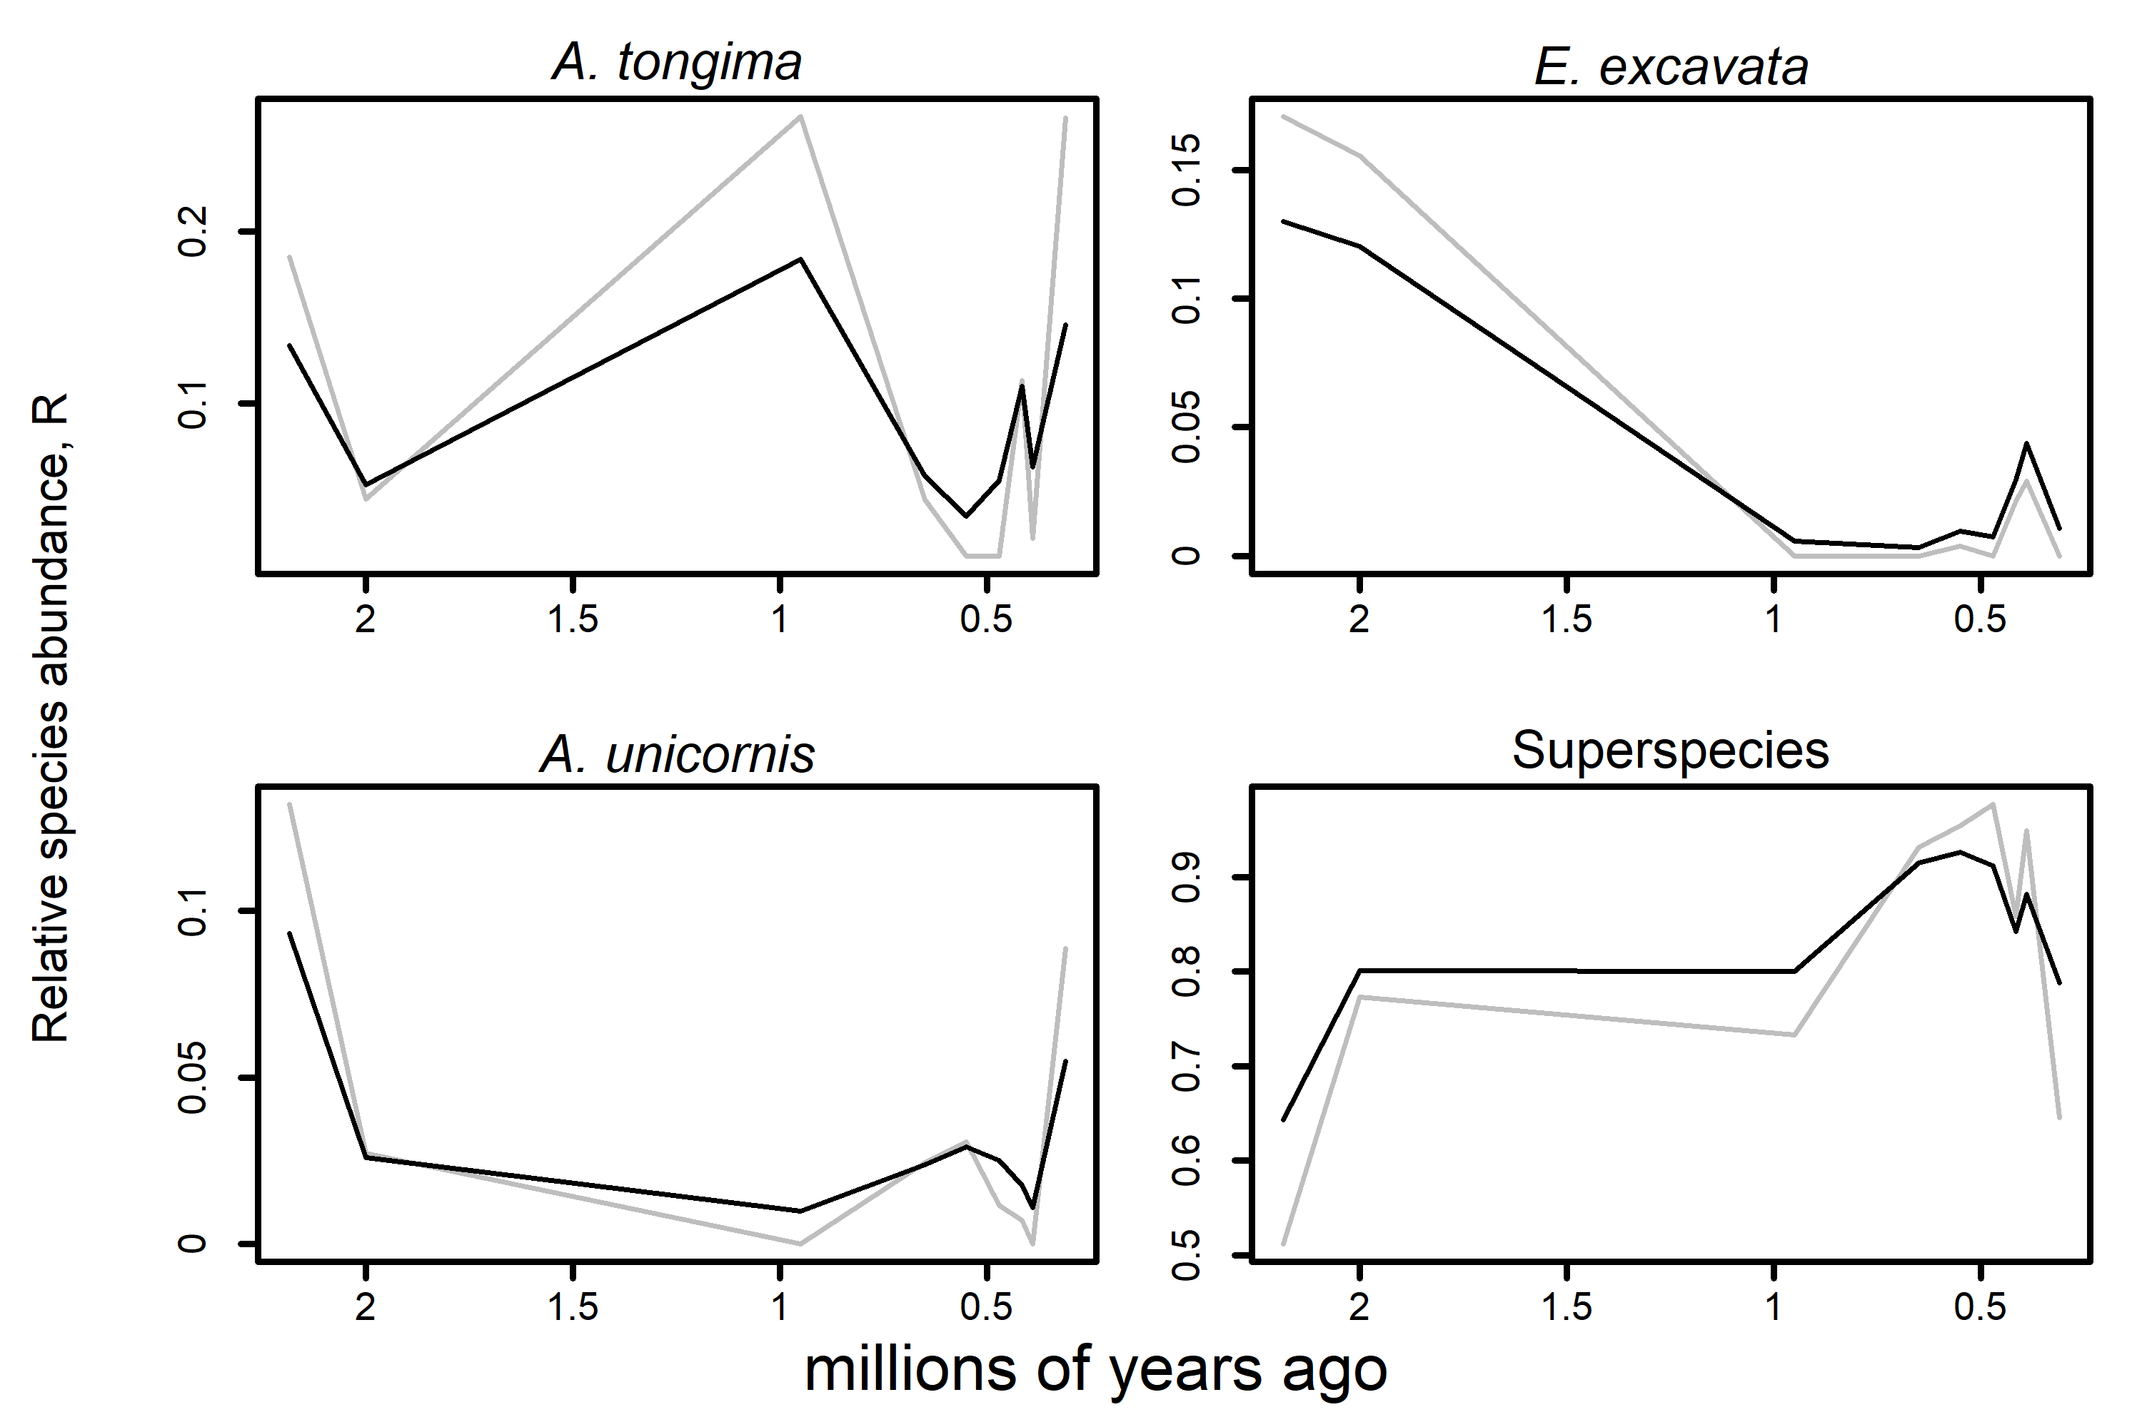

**Figure S3: Detection ratio-based versus full model R estimates.** Grey lines are detection ratio-based R estimates (see also Fig. S2) while black lines are full model R estimates.The temporal patterns are roughly similar. But simulation (Fig. 6) where underlying true values are known, show that full models are more accurate. Note that the difference between the older and younger estimates of R can be substantial, e.g. A. tongima.

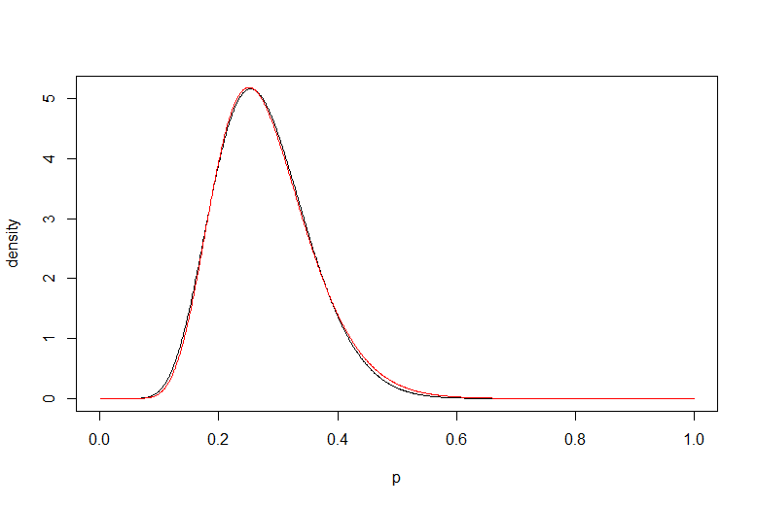

**Figure S4: Comparison of the probability densities for link models.**  Comparisons of a logit-normal distribution for the detection probability, p, (normal distribution with expected value -1 and standard deviation 0.4) and a cloglog-normal distribution adapted to the logit-distribution (using least squares on the probability density) are plotted, where the logit-normal distribution is in black and cloglog-normal distribution in red. This shows that there is little difference in the choice of the link model used in our main text (logit) and the alternative presented in SI (clogclog-normal).

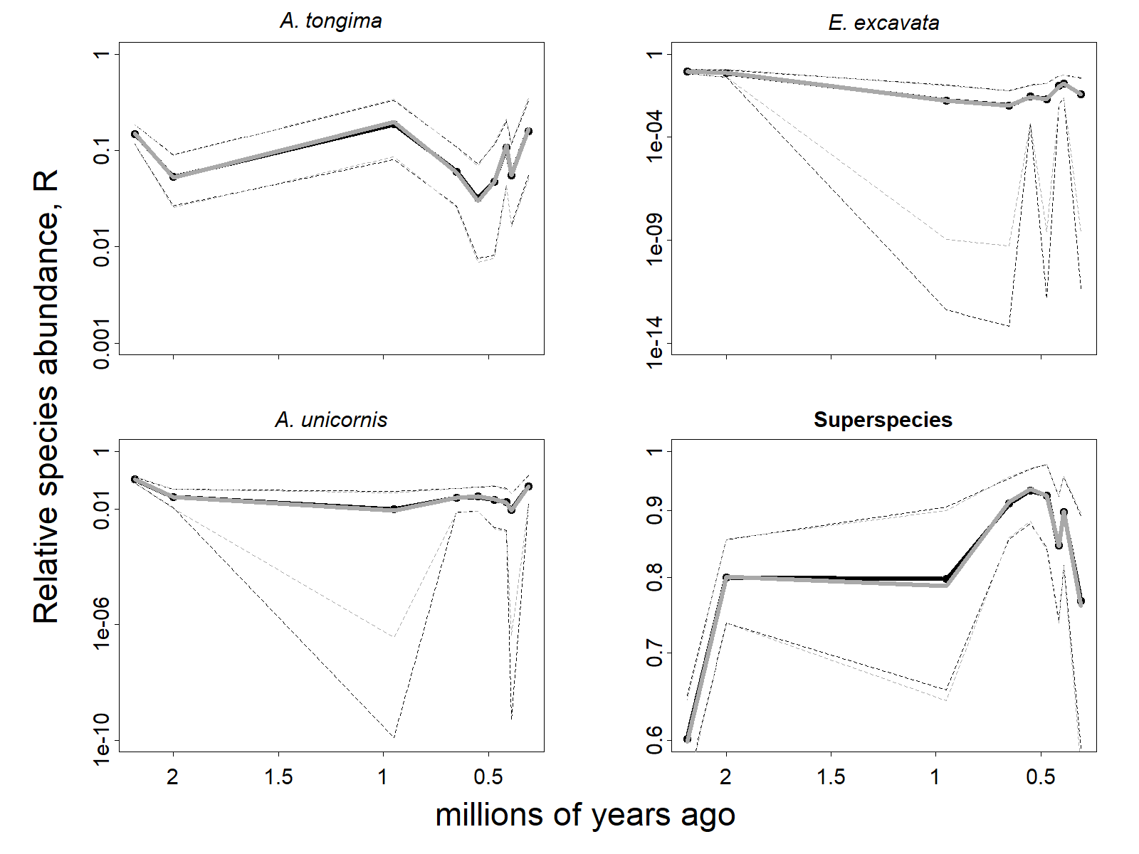

**Figure S5: Relative species abundance estimates and uncertainties for the main text model (and the abundance-focused model).** There is very little difference in the estimates for the main text full model (black) and abundance-focused model (grey). The lower uncertainty bands (dotted, with corresponding colors) are (on the log-scale) slightly different for some species for formations with a low number of sites.



**Figure S6: Comparisons of models with and without overdispersion**. Beta-binomial (overdispersed) distribution in black versus binomial (no overdispersion) distribution in red are shown for the estimated detection probabilities and overdispersion parameters for each species.



**Figure S7: Estimated formation-dependent detection random effects.** Random effect estimates common to all species, $u_{f}$, plotted against the midpoint of formation age ranges, shown in solid circles joined by solid line (the median is overlapped by the mean and cannot be seen). The open circles and dotted lines show the borders of the 95% posterior credibility intervals. Note that log-odds is the same as the logit-transformation.



**Figure S8: Estimated formation-dependent occupancy random effects.** Random effects estimate common to all species, $v_{f}$, plotted against the midpoint of formation age ranges, shown in solid circles joined by solid line (the median is overlapped by the mean and cannot be seen). The open circles and dotted lines show the borders of the 95% posterior credibility intervals. Note that log-odds is the same as the logit-transformation.



**Figure S9:** **Estimated formation-dependent detection random effects.** Estimated species- and formation-dependent detection probability random effects, $ε_{f,s}$, plotted against the midpoint of formation age ranges, shown in solid circles joined by solid line (the median is overlapped by the mean and cannot be seen). The dotted lines show the 95% posterior credibility intervals. Note that the yaxis are different in the four panels for visibility.



**Figure S10: Estimated species- and formation-dependent detection random effects.** Species- and formation-dependent occupancy probability random effects, $δ_{f,s}$, plotted against the midpoint of formation age ranges, shown in solid circles joined by solid line (the median is overlapped by the mean and cannot be seen). The dotted lines show the 95% posterior credibility intervals.

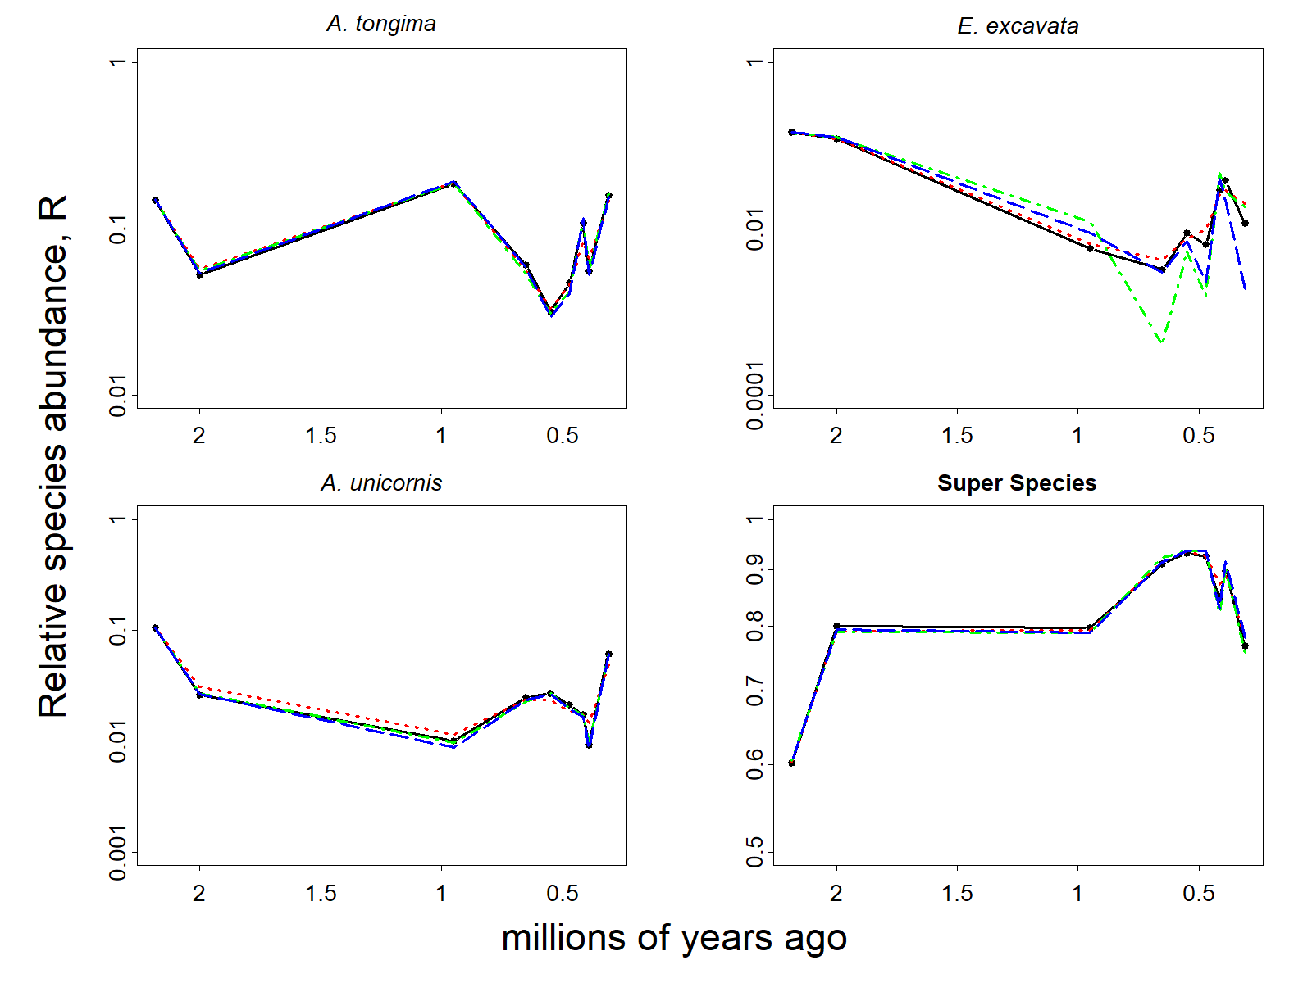

**Figure S11: Comparison of relative species abundance estimates for four models.** Panel plot estimates for each focal species and super species with model estimates superimposed. Note that the y-axes are different for visibility. Black solid line=full model, red dashed line=OU (auto-correlation) model, green dash/dotted line=model with as detection probability explanatory variable, blue dashed line=model with Mg/Ca as detection probability explanatory variable.

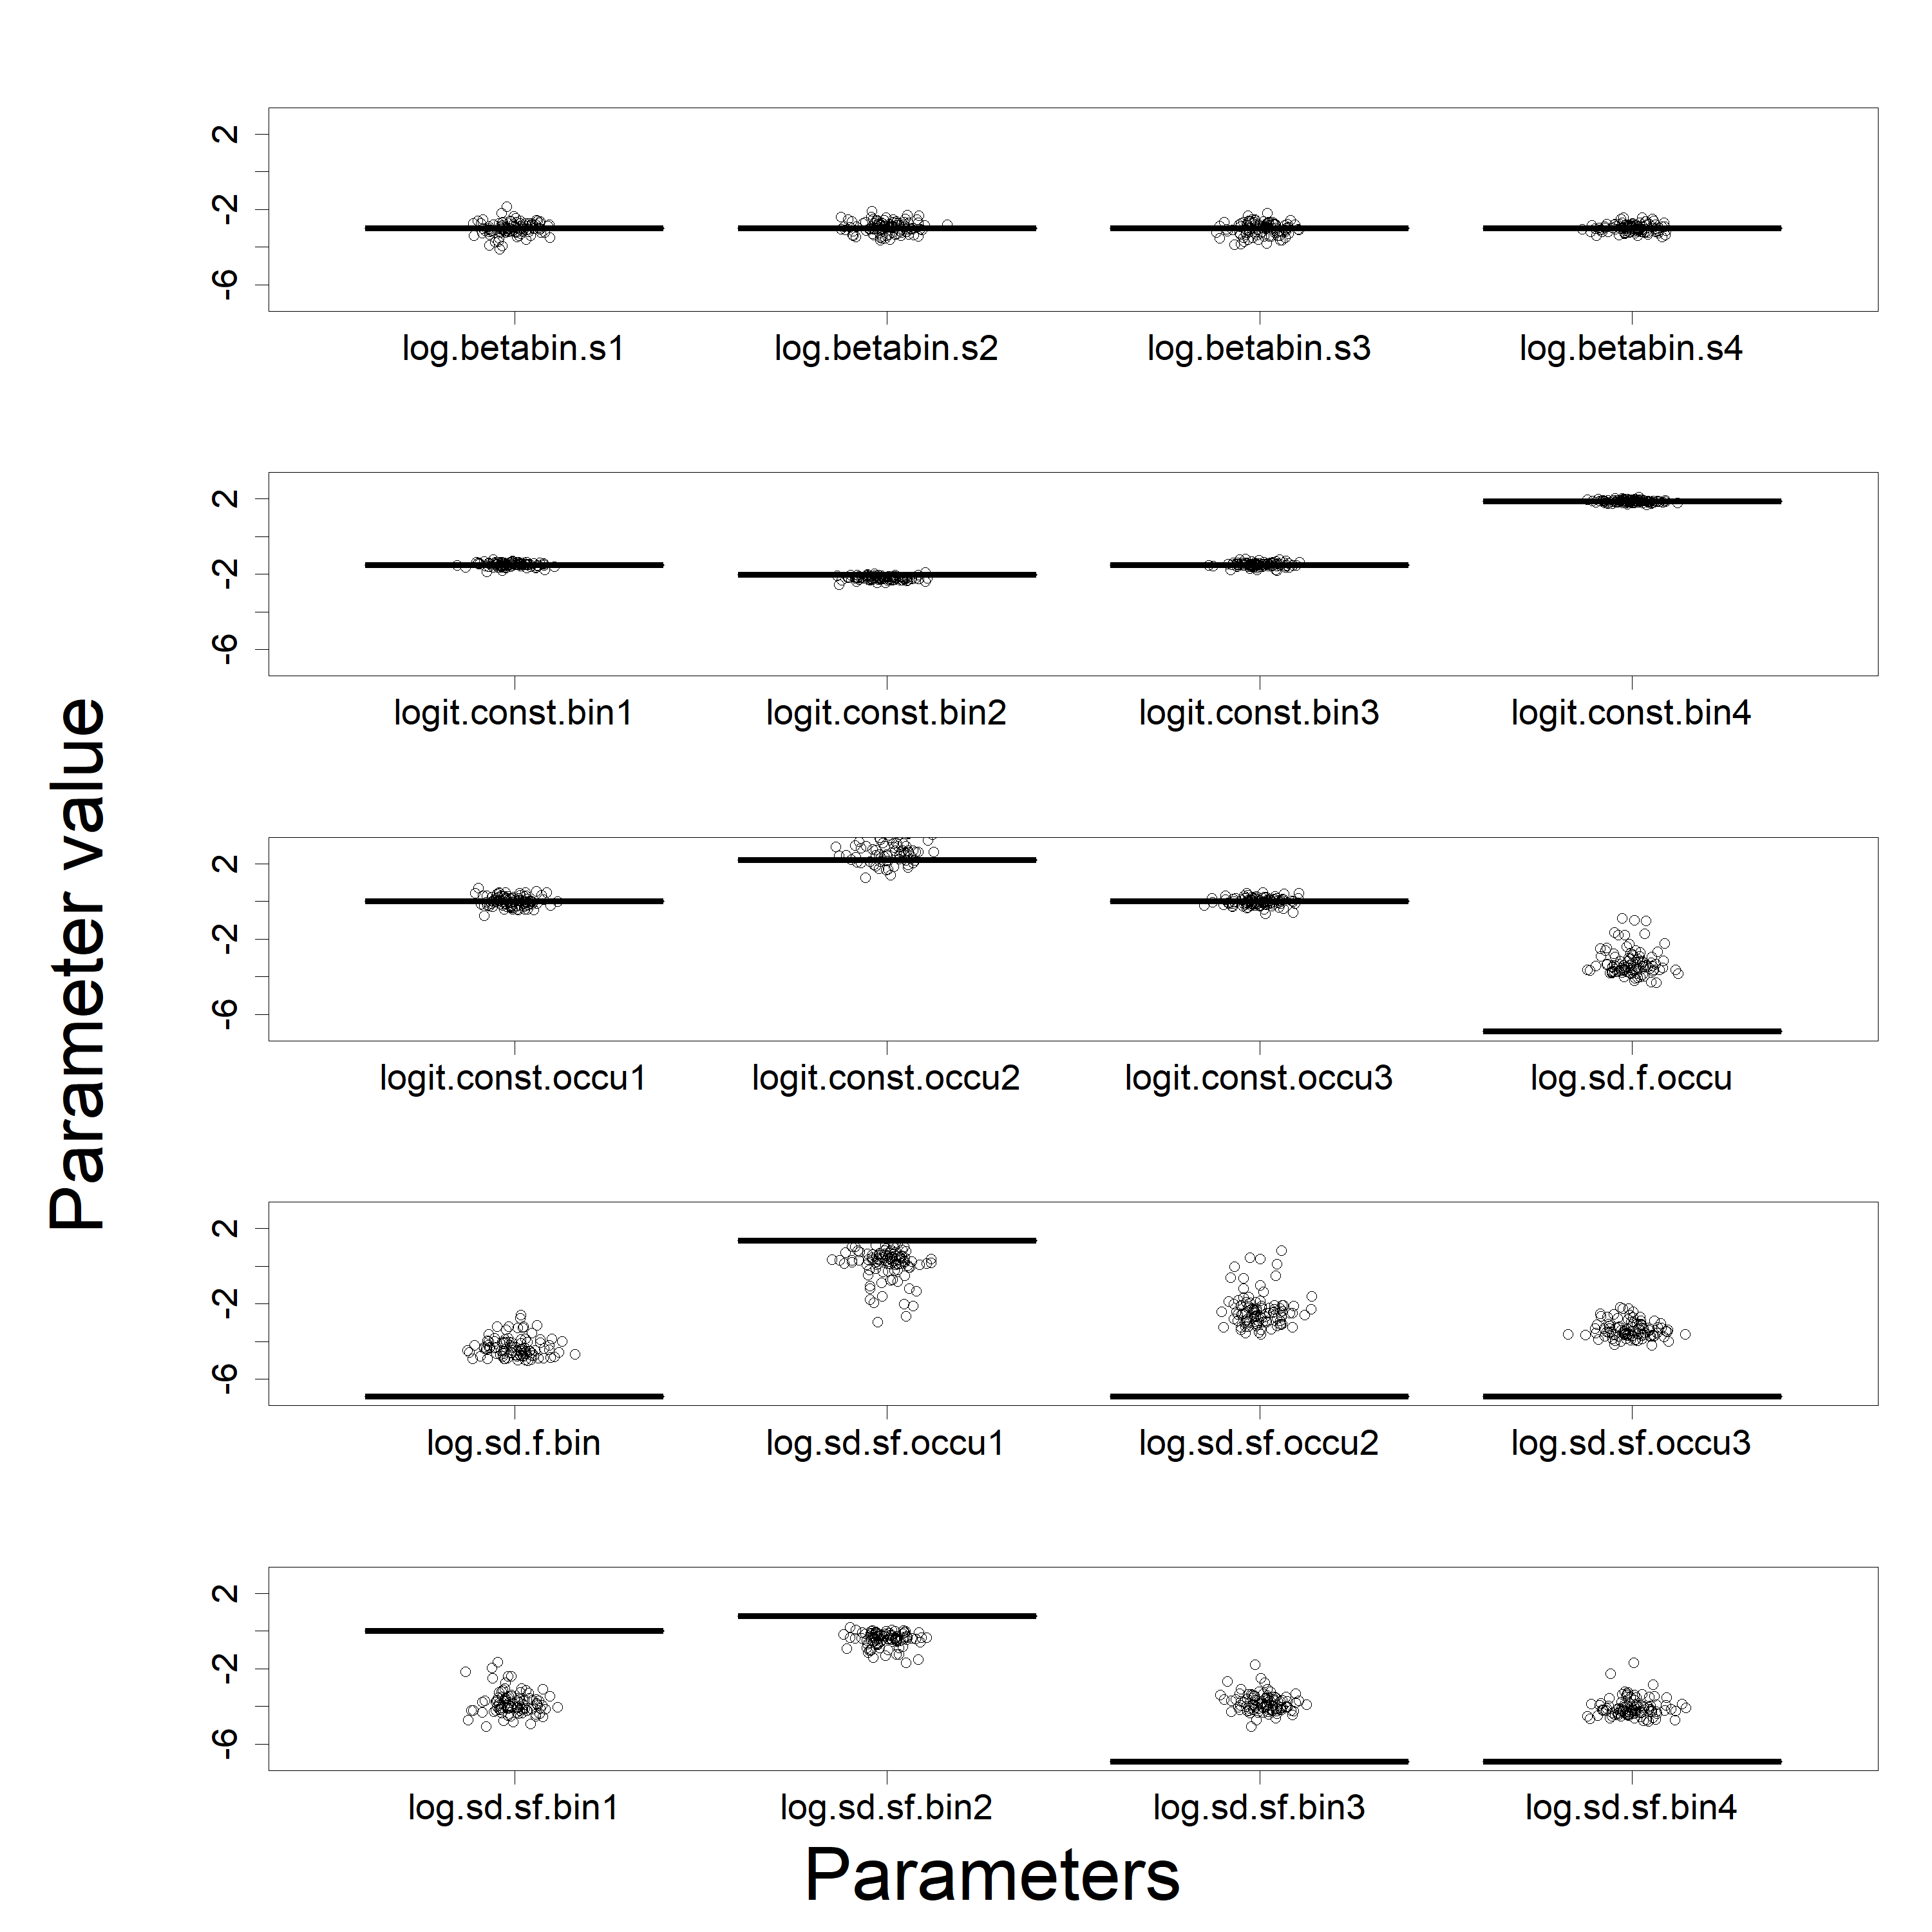

**Figure S12: Top parameter values for the abundance-specified simulation study.** Horizontal lines are the actual parameter values, while the dots are the estimates from the 100 datasets. Log.betabin.s1… …log.betabin.s4 are the overdispersion parameters on the log-scale for species 1 through 4 (${log⁡(κ}_{1)},⋯,{log⁡(κ}_{S})$); logit.const.bin.1 … … logit.const.bin.4 are the overall detection (binomial) probabilities on the logit-scale for species 1 through 4 ($β_{1},⋯,β_{S}$); logit.const.occu1 … … logit.const.occu3 are the overall occupancy probabilities on the logit-scale for species 1 through 3 ($α_{1},⋯,α_{S-1}$); log.sd.f.occu is the standard deviation on the log-scale of the formation-dependent occupancy random effects ($log⁡(σ_{v})$); log.sd.f.bin is the standard deviation on the log-scale of the formation-dependent detection random effects (${log⁡(σ}_{u})$); log.sd.sf.occu1 … … log.sd.sf.occu3 are the standard deviations on the log-scale of the species-and formation-dependent occupancy random effects for species 1 through 3 (${log⁡(σ}_{δ,1}),⋯,{log⁡(σ}_{δ,S-1)}$); log.sd.sf.bin1 … … log.sd.sf.bin4 are the standard deviations on the log-scale of the species- and formation-dependent occupancy random effects for species 1 through 4 (${log⁡(σ}_{ε,1}),⋯,{log⁡(σ}_{ε,S})$). See also the full model description in Eq. 5 and Fig. 2 in the main text.

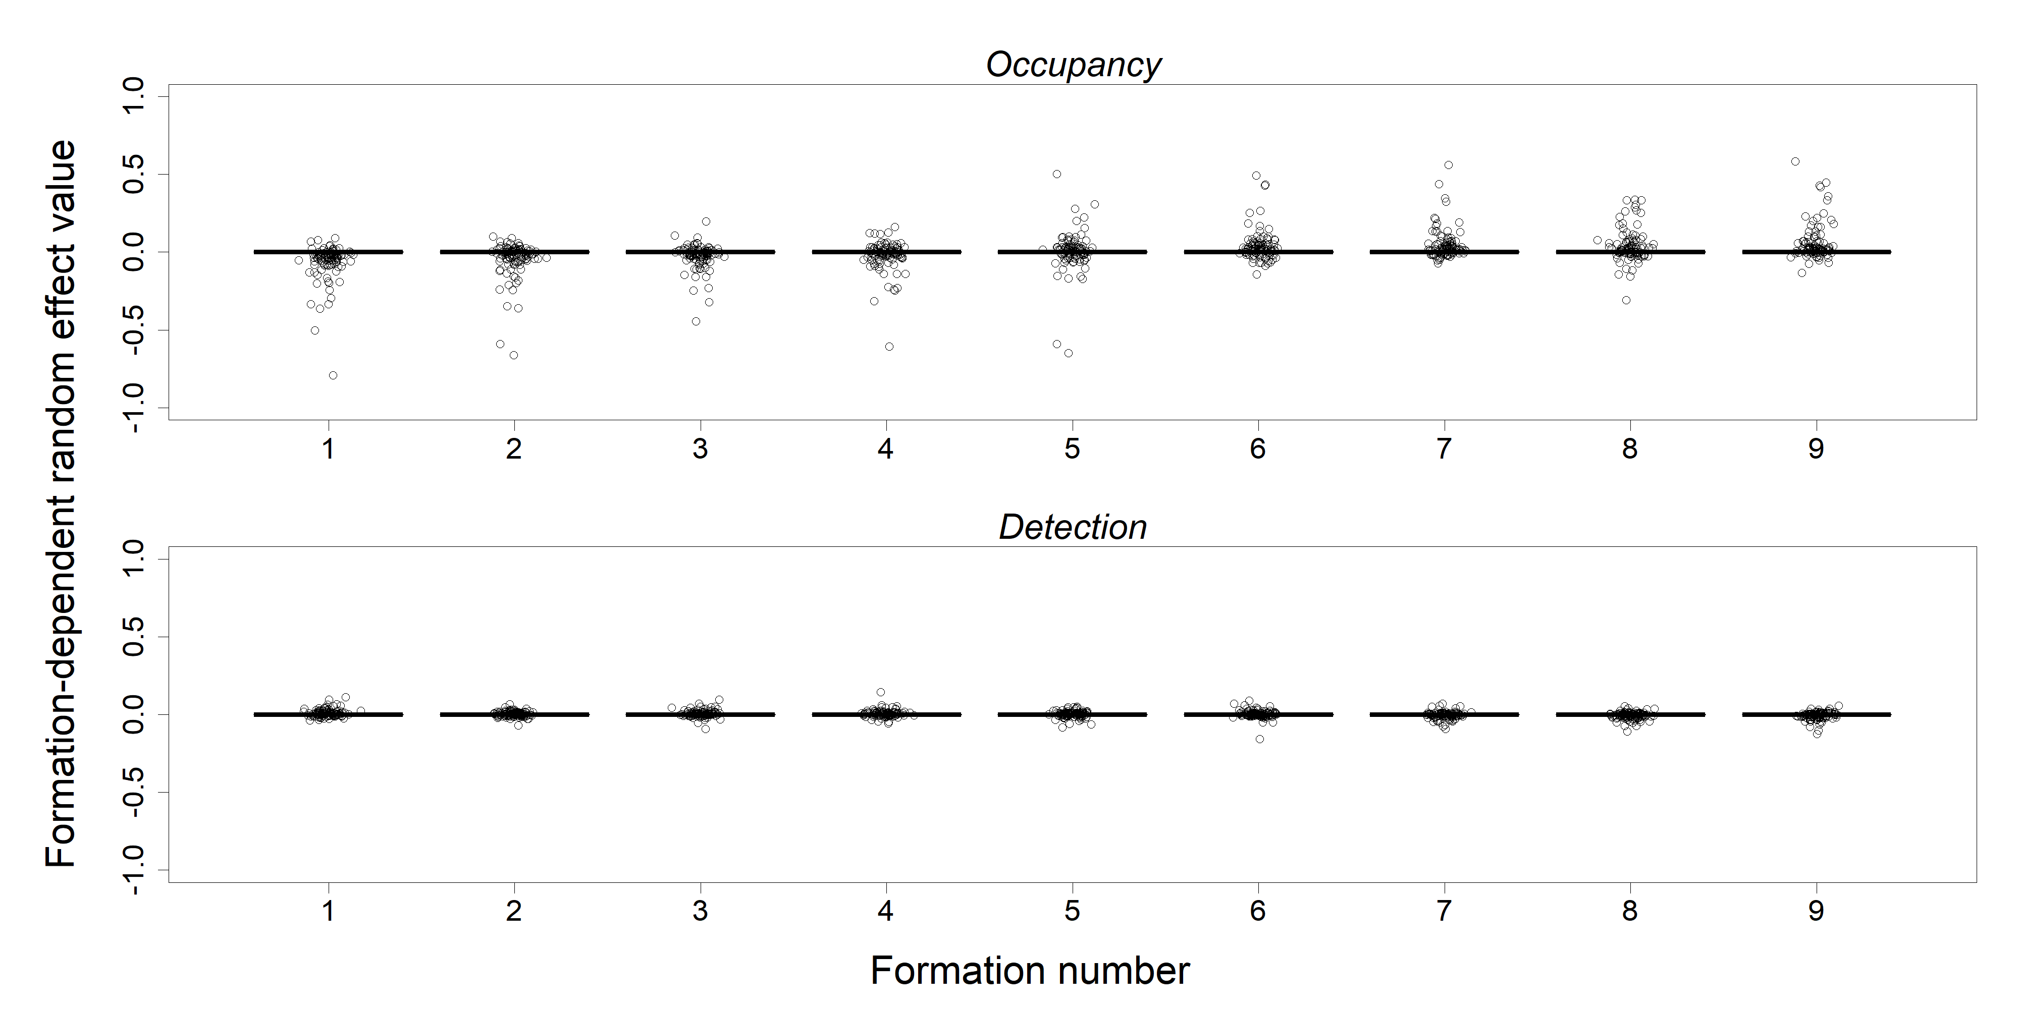

**Figure S13: Formation-dependent random effects for the abundance-specified simulation study.** Horizontal lines are the actual parameter values, while the dots are the estimates from the 100 datasets.

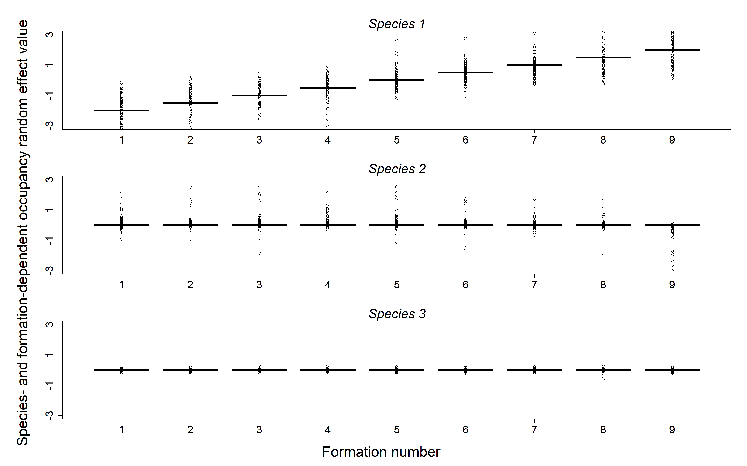

**Figure S14: Species- and formation-dependent occupancy random effects for the abundance-specified simulation study.** Horizontal lines are the actual parameter values, while the dots are the estimates from the 100 datasets.

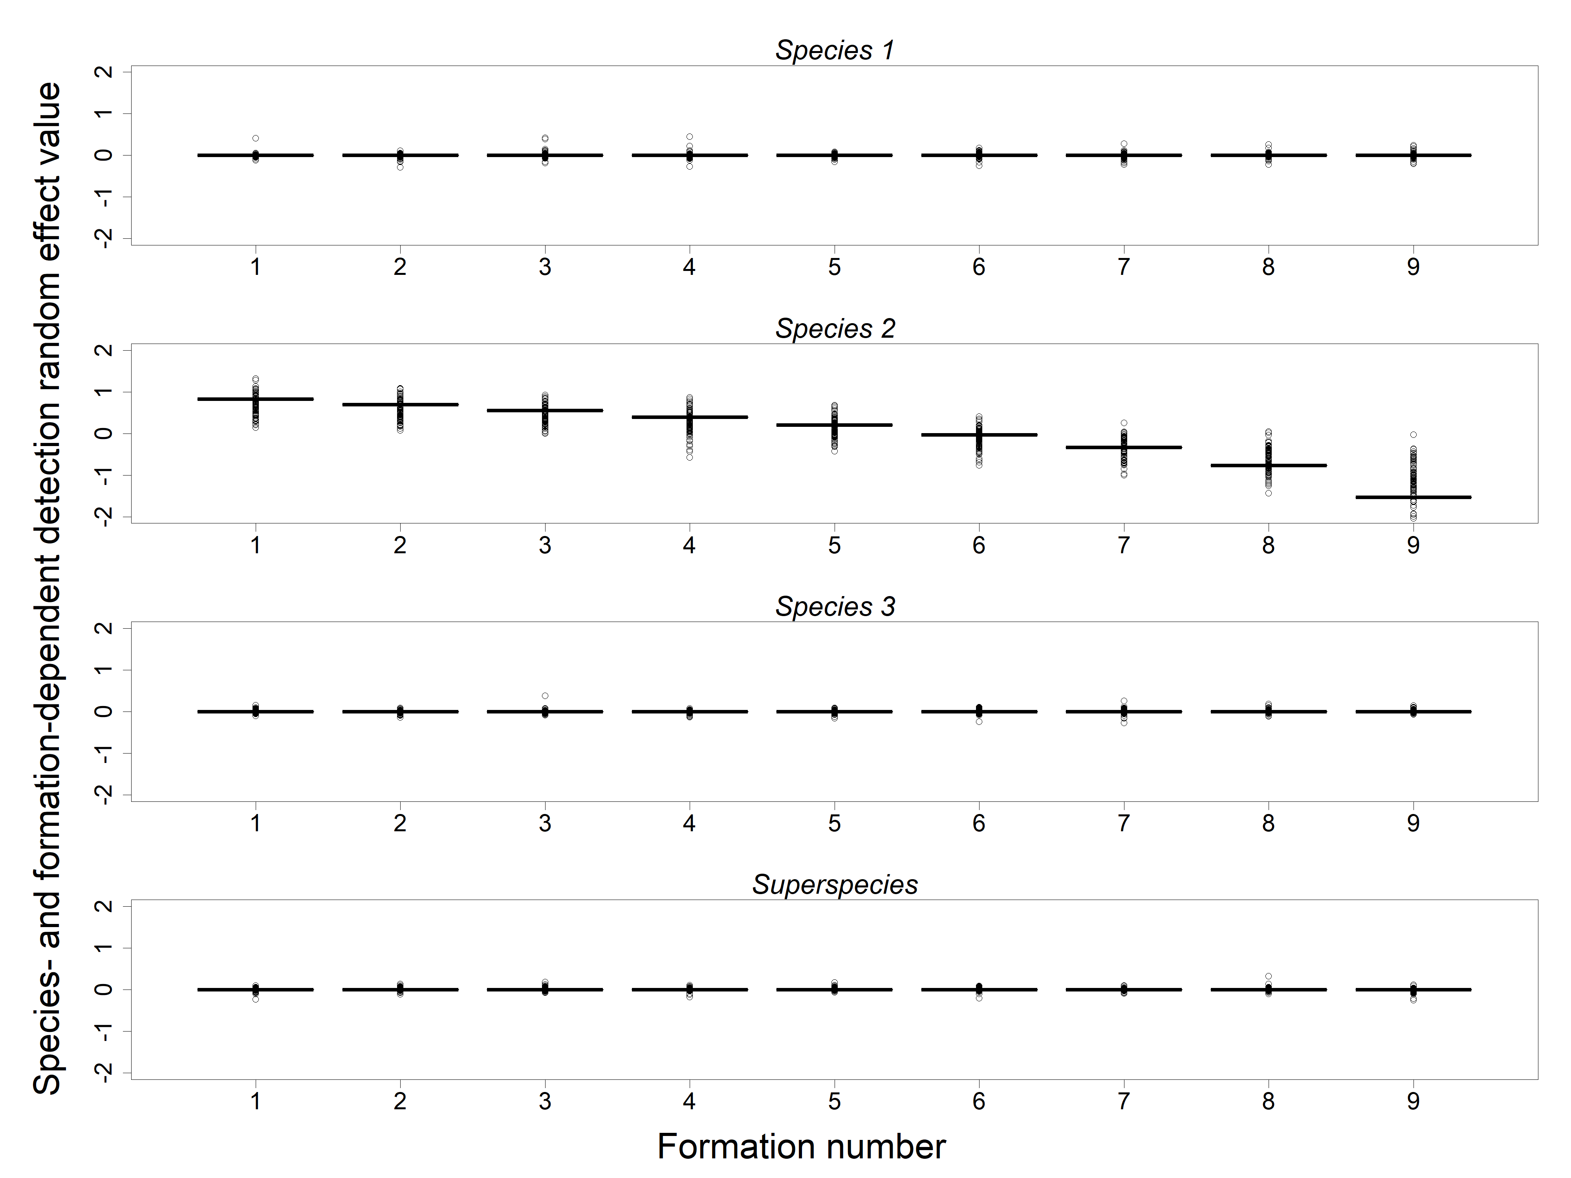

**Figure S15: Species- and formation-dependent detection random effects for the abundance-specified simulation study.** Horizontal lines are the actual parameter values, while the dots are the estimates from the 100 datasets.

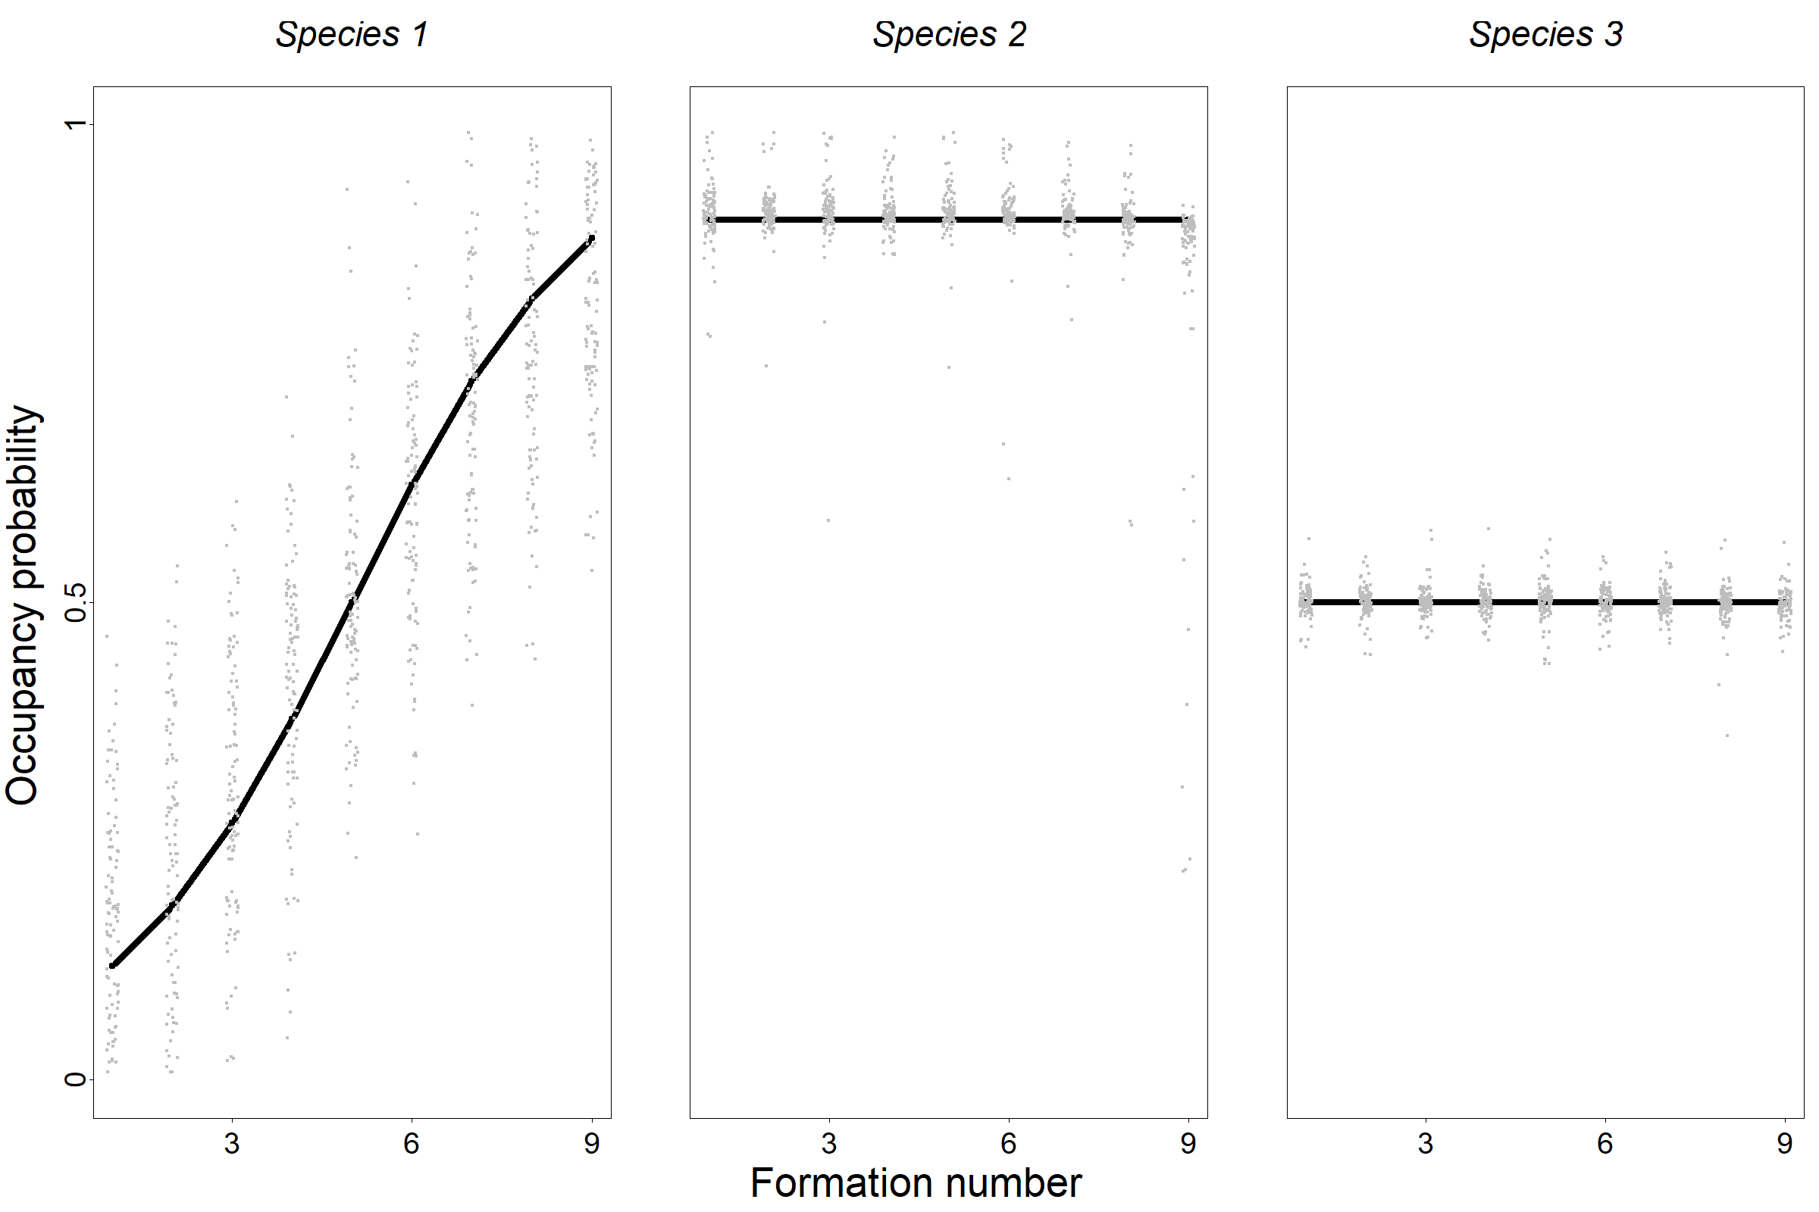

**Figure S16:** **Occupancy probabilities for the abundance-specified simulation study.** Solid lines show the actual occupancy probabilities for the various species and formations, while the points are estimates from the 100 simulated datasets.

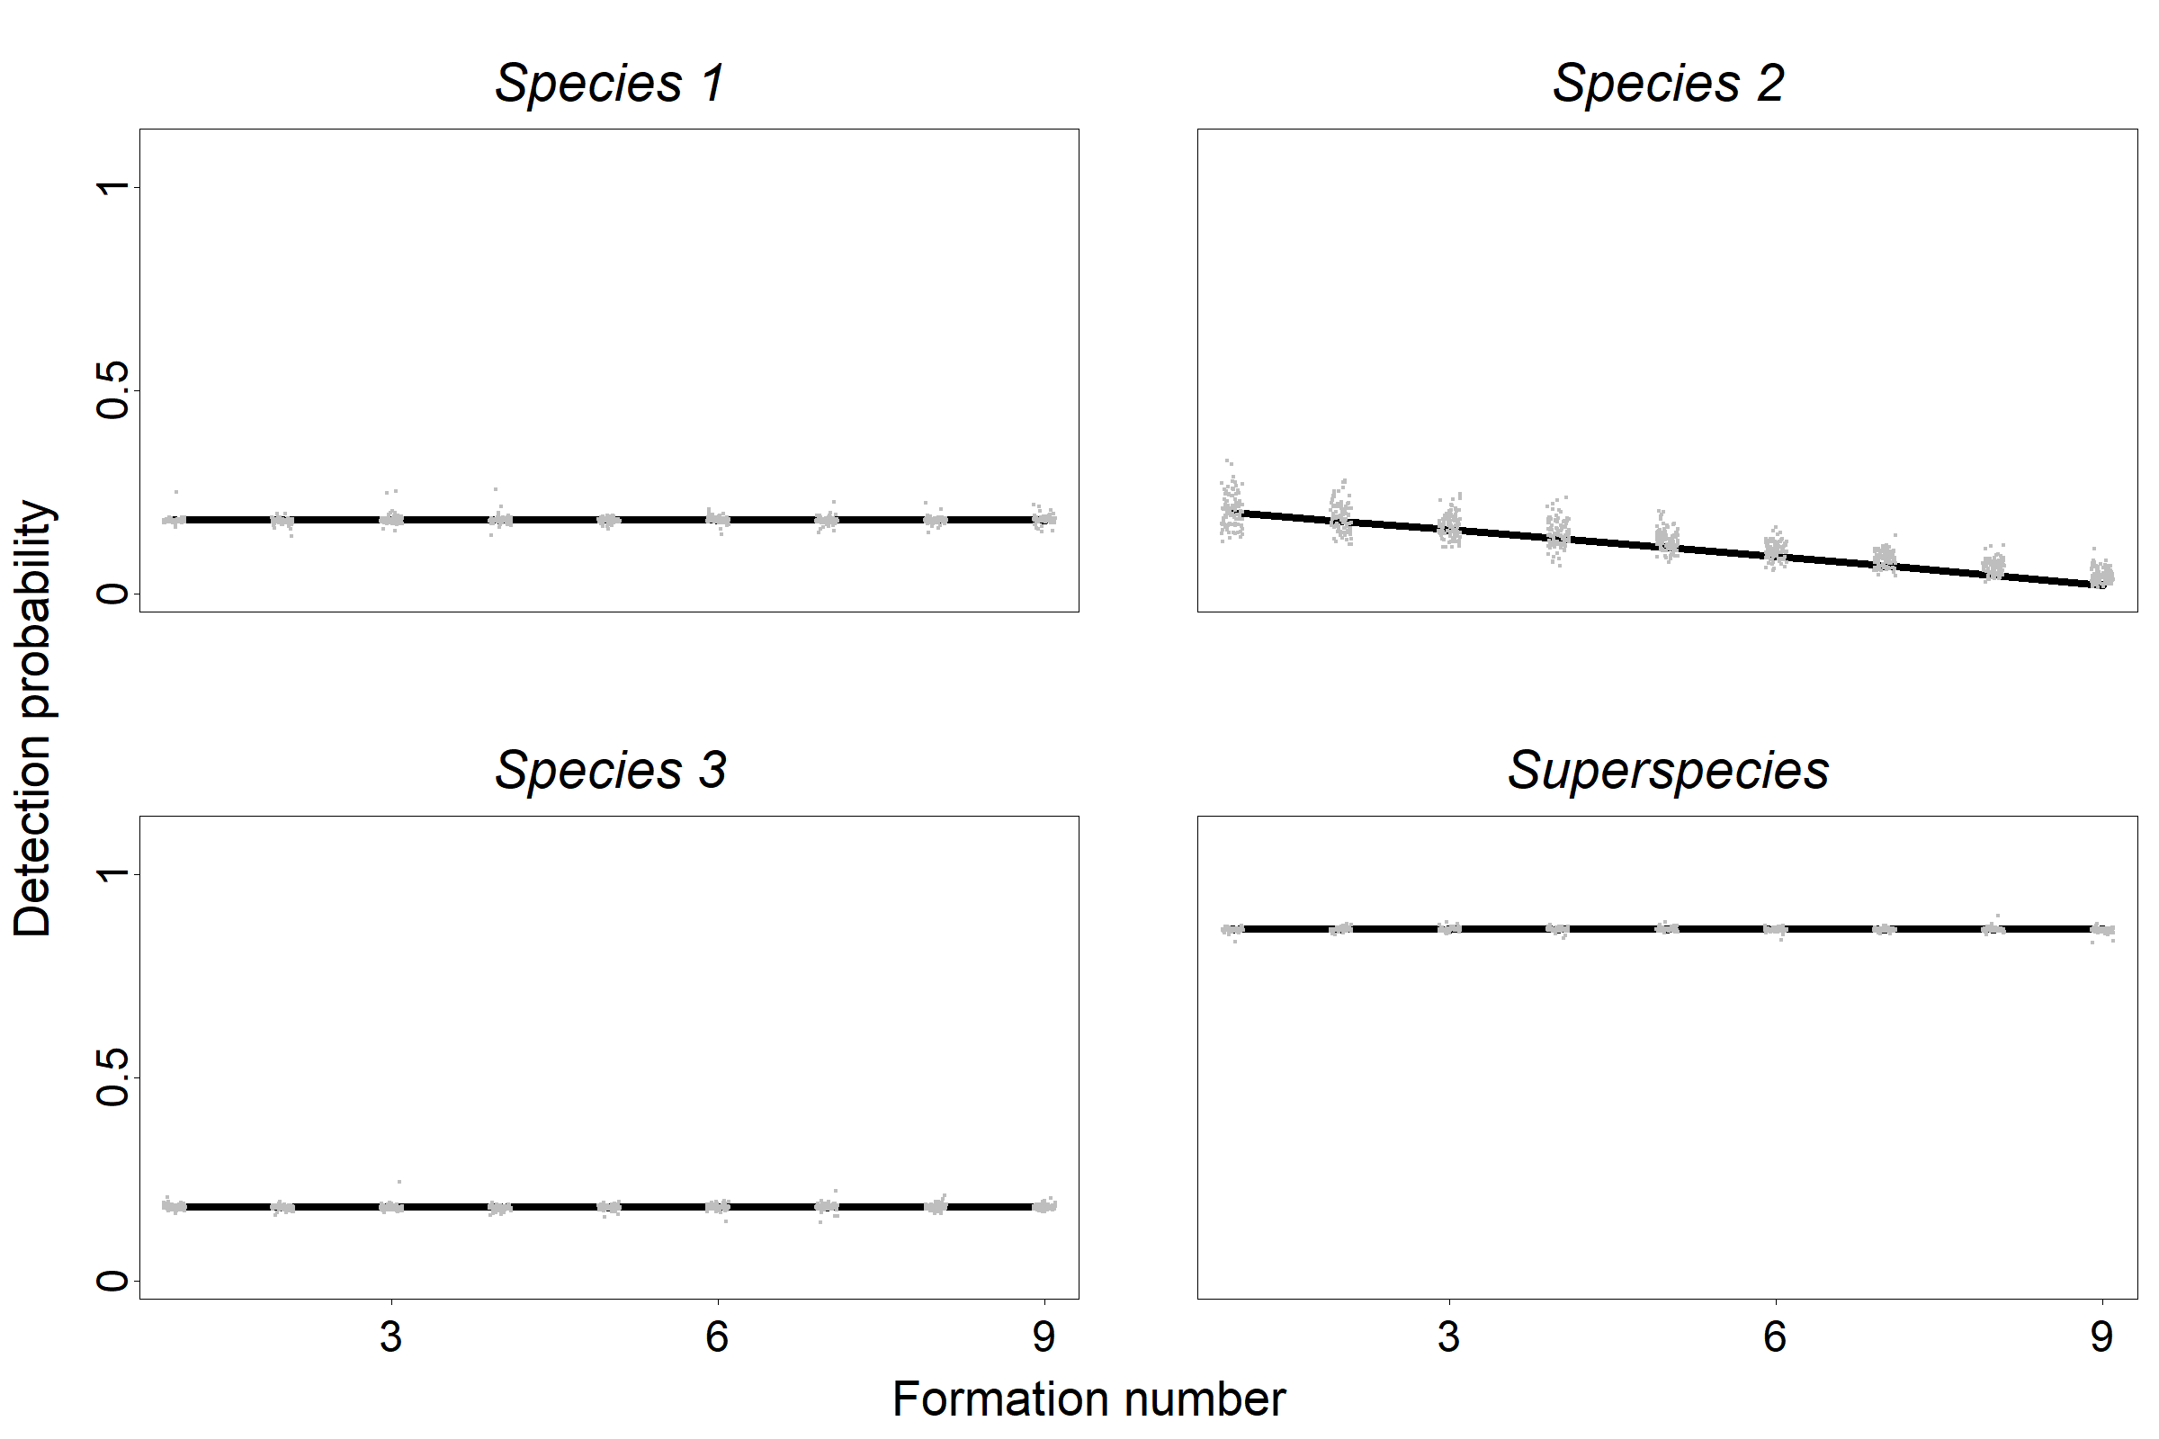

**Figure S17: Detection probabilities for the abundance-specified simulation study.** Solid lines show the actual detection probabilities for the various species and formations, while the points are estimates from the 100 simulated datasets.

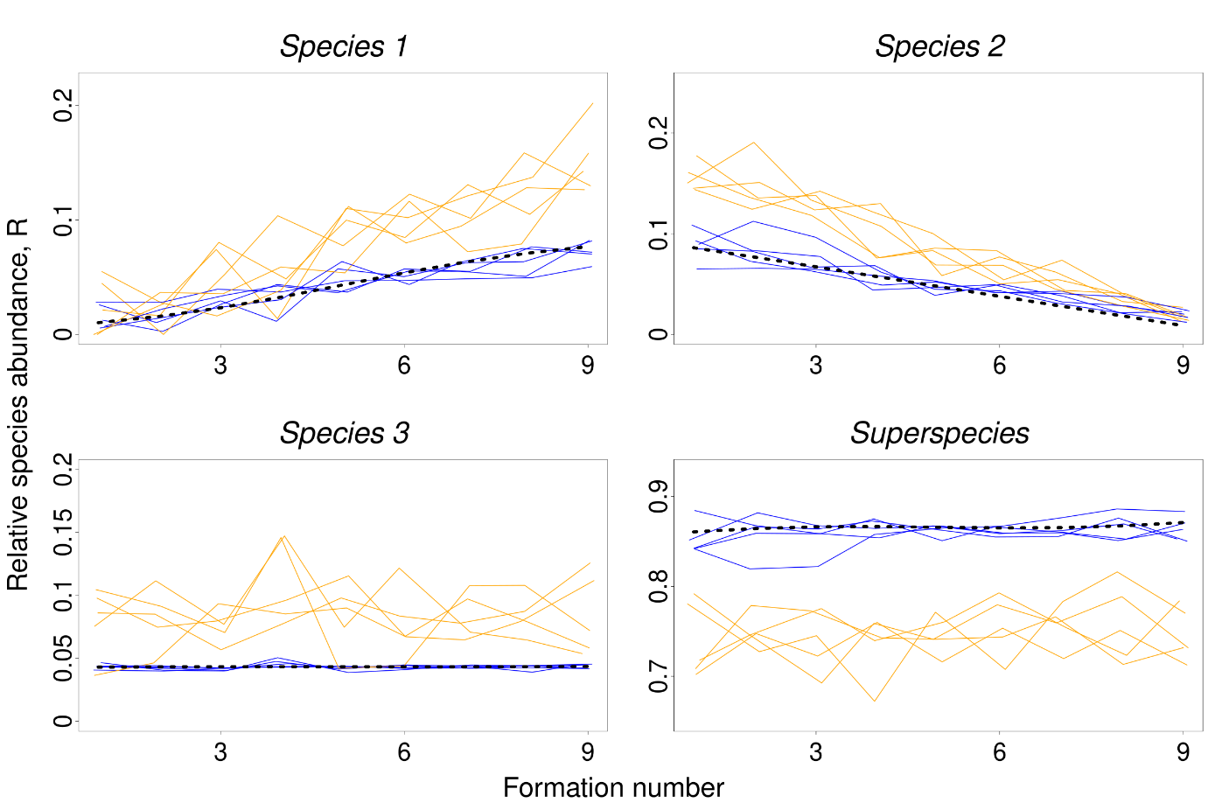

**Figure S18: Relative species abundances dynamics examples for the abundance-specified simulation study.** Black dashed wise lines lines show the true relative species abundances for the various species and formations, blue lines show the inferred dynamics using the full model estimates and orange lines show detection ratio based estimates, each for 5 simulations.

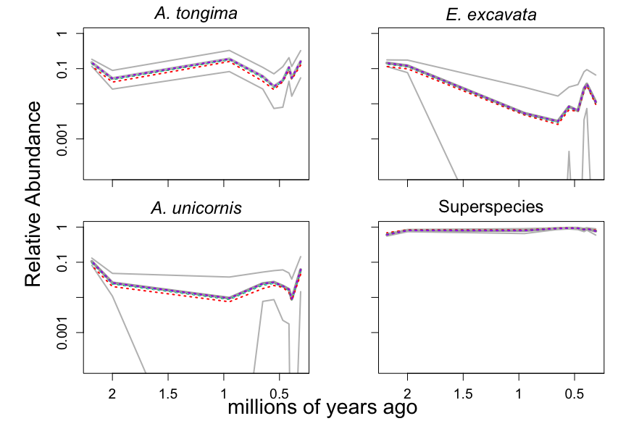

**Figure S19: Relative species abundance for different link functions between abundance and detection probability due to overdispersion of number of colonies per subsample.** Black line=no overdispersion (Poisson process link described in Eqn 7 in the main text, negative binomial overdispersion parameter $→∞$), purple line=overdispersion 100 (very high value for the overdispersion parameter), yellow line=overdispersion 12 (highest single species estimate), blue line=overdispersion 4 (upper uncertainty confidence band for overall overdispersion), green line=overdispersion 3 (lower uncertainty band for overall overdispersion), red line=overdispersion 1 (lowest single species estimate). The grey lines represent the 95% posterior credibility bands for the Poisson assumption (Eqn 7 in the main text).